2018 ANNUAL REPORT ON SEXUAL VIOLENCE/SEXUAL HARASSMENT: PREVENTION, INCIDENCE, AND RESPONSE
University of California, Berkeley

Forward

As UC Berkeley’s 11th Chancellor, one of my first actions was to commission an annual report on sexual violence and sexual harassment (SVSH). This report will enable our campus, and the broader community, to reflect on the efforts that are being made. Honest assessment is necessary as we continue to learn and improve.
SVSH is an issue to which I have been attuned for much of my career. As Chancellor, I have made it a priority to strengthen and increase awareness of the practices on our campus for preventing and responding to SVSH.
SVSH has a deep impact on survivors and on the community they live and work in. SVSH is fundamentally at odds with our society’s principles of equality and fairness. And it is fundamentally at odds with the mission of a university, which is to draw on the talents of the entire community to promote creativity and intellectual growth.
This report reflects the voices of many contributors to our campus. I am grateful for the hard and heartfelt work that they do - and to you, the reader, for your interest in this important topic.
Fiat lux!
Carol T. Christ
Chancellor, University of California, Berkeley

1.0. Preface
This first-ever Annual Report on Sexual Violence/Sexual Harassment presents a portrait of a crucial moment in campus history. A crescendo of interest across the campus community in holding the campus accountable to its values coincided with the appointment of Carol T. Christ, in 2017, as the first female chancellor in Berkeley’s history. Chancellor Christ’s stated commitment to changing the culture on campus preceded by mere months a surge in the #metoo movement, which galvanized the nation, focusing attention on the impact of sexual harassment and sexual assault.
This report focuses not on the nation but on the Berkeley campus, describing the current state of the campus in the context of its history and aspirations for its future. The contents of this report showcase the hard work of many, from activists who have made inspired calls for change, to administrators who have brought change to bear, to staff and students who work every day to support survivors, and to all those in the community who infuse the Berkeley principles of community into their daily activities.
Sexual harassment and sexual violence are at odds with the basic mission of the university: to teach, to create, to discover, and to inspire, in a truly inclusive manner. By surveying campus efforts as broadly as possible, this report models the philosophy that preventing sexual harassment and violence is a community responsibility.
Sharon Inkelas
Special Faculty Advisor to the Chancellor on Sexual Violence/Sexual Harassment and Professor, Department of Linguistics

2.0. Executive Summary
The current landscape of Sexual Violence and Sexual Harassment (SVSH) at UC Berkeley is a product both of its history and of its goals for the future. It is intended to provide accessible information about prevention, response, investigation, and adjudication to the Berkeley campus community and beyond.
The report focuses on four key areas: prevention, survivor support, incidence rates, and response.

Prevention.
SVSH affects the entire community; conversely, preventing SVSH is a community responsibility. Section 5 of this report portrays the multifaceted education effort on campus, ranging from required training for new and continuing students and employees to enrichment opportunities available to different groups on campus. The Berkeley campus is the size of a small city (over 56,000 students and employees). Reaching every member of the community requires a rich patchwork of efforts, many of which are described in this section.

Survivor support.
When SVSH occurs, it is essential that survivors receive the care and support they need to begin the healing process. Survivor support resources on campus are the focus of section 6. Multiple offices on campus provide survivor support services for students, faculty, and staff who have been impacted. This report explains the individual functions of these offices as well as the student groups that deal most frequently with prevention and response to SVSH issues.

Incidence rates.
SVSH is a very complicated problem, making data about its incidence challenging to obtain. Section 8 of this report examines incident rates through multiple lenses: the number of formal reports to the university, data regarding utilization of support services, and incident rates from the 2018 MyVoice survey of the entire campus. Each of these data sources contributes to understanding the need for prevention efforts, support services, and a transparent process for responding to SVSH, through investigation, adjudication, and remediation.

Response.
Section 7 of this report explains and presents data regarding the campus response to SVSH incidents that are reported to the campus Title IX office. It is essential to have a fair and transparent process of reporting, investigation, and adjudication.
Describing the process clearly is a challenge, given its complexities. Section 7 focuses on key elements of the response process and the types of resolution that are possible when a complaint has been made to the Title IX office. Section 7 also provides data about caseloads and outcomes at the Title IX office on campus as well as the offices that subsequently adjudicate policy violations.

3.0. Introduction and Aims
This report is a portrait of the landscape at the University of California at Berkeley regarding SVSH, an acronym which literally expands as “sexual violence and sexual harassment” but which is used to encompass a broad spectrum of experiences individuals on our campus may face. These include, but are not limited to, relationship (domestic and dating) violence, sexual assault, sexual harassment, stalking, and retaliation against those who have reported misconduct.

3.1. Goals of report
This report is designed to illuminate the network of individuals, offices, and groups that dedicate themselves to preventing and responding to SVSH on campus. The report is also a history of how we got where we are and collects our aspirations for a better future. It represents a commitment to hold ourselves accountable for changing campus culture to one in which SVSH is never tolerated, and in which incidents that do occur are responded to effectively.
UC Berkeley is not alone in exploring solutions to the problem of sexual violence and harassment. The national academic community is researching, theorizing, and collaborating in hopes of discovering proven, effective prevention strategies on college campuses. This report draws on recommendations from the Center for Disease Control, National Academies of Science, and research used to create and launch the MyVoice Survey. Both of the aforementioned organizations suggest that it is important to the improvement of universities to evaluate their progress, in reports such as this.
This report is intended for anyone who cares about the UC Berkeley community. By painting a rich picture of the situation as it exists, we can help the campus live up to its principles. This is the first Annual Report on SVSH at UC Berkeley. Future iterations will make it possible track our progress.
This comprehensive report is not a short read, nor is it necessary to read from beginning to end. Readers may want to dip into particular sections to read about what interests them most.

3.2. Guiding values
UC Berkeley’s approach to SVSH prevention and response is shaped by the following guiding values, which are reflected in the structure of this report.

3.2.1. A prevention focus
Knowing that organizational climate can foster or prevent harassment and harm, UC Berkeley is dedicated to providing prevention education and consultation to students, faculty and staff. This report presents data on coordinated campus wide prevention efforts as well as initiatives developed for specific communities. Our campus utilizes a primary prevention approach, focusing on the ability of the university, and communities within it, to prevent harm from occurring before it happens.

3.2.2. Centering Survivors
This report, like the many efforts on campus that it surveys, acknowledges the experiences of survivors in the community. Tangibly, the report centers survivors with its focus on survivor support services at the PATH to Care Center, Social Services counselors, and other campus-based groups and offices.

3.2.3. Illuminating a complex system
By presenting the specific reporting processes for student, faculty, and staff in comprehensible ways, the report sheds light on the processes of reporting, investigating, and adjudicating. This information is important to survivors and those accused, as well as to community members, in order to understand how the university holds individuals accountable for their actions while maintaining a fair and neutral process and protecting the safety of all.

3.2.4. Seeking to improve
It is important to identify and acknowledge gaps in our practices and efforts in order to sustain progress. This report recognizes the work of the many dedicated activists and practitioners on campus, while naming areas of growth such that efforts for improvement can continue. The report illuminates hard work that is often done behind closed doors by staff - those who support survivors, counsel the accused, and conduct investigations and adjudications - who are at constant risk of burnout due to limited resources, increasingly high workloads, and vicarious trauma.

3.2.5. Addressing SVSH is a community responsibility
Lastly, this report is a call to action for every individual on campus. Sexual and relationship violence, stalking, and sexual harassment are community-level issues, and accordingly require community-level prevention strategies. When someone experiences SVSH, it doesn’t impact that individual in isolation, particularly when it takes place in a learning or working environment. Using a prevention lens, it is clear that the widespread impact of SVSH provides all members of the community with opportunities to prevent harm from happening.
UC Berkeley can become a community of active bystanders, informed friends and partners, respectful research environments, and a safe place to advance intellectually and personally. However, to cultivate that vision of our campus, each person must commit to uphold the values of the campus.

Berkeley Principles of Community
(diversity.berkeley.edu/principles-community)
- We place honesty and integrity in our teaching, learning, research and administration at the highest level.
- We recognize the intrinsic relationship between diversity and excellence in all our endeavors.
- We affirm the dignity of all individuals and strive to uphold a just community in which discrimination and hate are not tolerated.
- We are committed to ensuring freedom of expression and dialogue that elicits the full spectrum of views held by our varied communities.
- We respect the differences as well as the commonalities that bring us together and call for civility and respect in our personal interactions.
- We believe that active participation and leadership in addressing the most pressing issues facing our local and global communities are central to our educational mission.
- We embrace open and equitable access to opportunities for learning and development as our obligation and goal.

3.3. History: how did we get here?
Sexual and relationship violence, stalking, and sexual harassment have impacted members of the Berkeley community, and society at large, since its founding. Although it is not possible to trace these issues through the entire history of campus in this report, acknowledging how we got here and learning from the past is essential to progress.
The history of SVSH prevention and response structures on university campuses is largely a combination of federal guidance (Title IX, in particular) and local campus activism. In 1983, the current chancellor, Carol T. Christ, was serving, in her role as Faculty Assistant to the Chancellor for the Status of Women, as the second-ever Title IX Compliance Coordinator. That role has since evolved substantially. The campus named its first full-time Title IX Officer in 1989, charged with handling sexual harassment complaints and carrying out prevention training. In 2010, the Title IX Officer took on the oversight of Title IX athletics compliance, and in 2011, assumed responsibility for handling sexual assault complaints, in addition to sexual harassment. As of 2018, UC Berkeley’s Title IX office is staffed with professionals trained in SVSH investigations, and enforces the systemwide UC Policy on SVSH as well as ensuring campus compliance with Title IX. Laws and campus policies have improved, with the passing of the Clery Act, Campus SaVE, Violence Against Women Act, and SB 967. Some laws require training for all students and employees, and others require training for supervisors regarding the prevention of sexual harassment, discrimination and retaliation.
Periodically, and especially within the past five years, many students, faculty, and staff have expressed to the Berkeley administration and the UC system at large their wishes to further strengthen policies, processes and resources for dealing with sexual violence and sexual harassment on campus. This section briefly discusses some of the many initiatives geared toward this goal.

3.3.1. Student activism
In the years between 2013 and 2016, a wave of student-driven activism sparked change across the nation, which also resonated on the Berkeley campus. Students who felt the campus response to SVSH cases had been inadequate put pressure on the UC system in a number of ways. The ASUC demonstrated their dissatisfaction with the UC Berkeley systems in place for handling SVSH cases on campus with a vote of no confidence. Complaints filed by students resulted in federal and state investigations by the Department of Education (OCR/Clery) and the California State Auditor. Students spoke out publicly about their own experiences as well as the problem in general, engaging interest from the press and broader community. Due in part to this activism, the Berkeley campus, along with many others, was included in the 2015 documentary The Hunting Ground, which trained a spotlight on the problem of sexual assault on college campuses.
Building upon decades of prior anti-violence organization, student activists nationally used their own stories to lay a foundation for the
#metoo movement, which explored violence and harassment in other spheres, such as the workplace. This series of events marked a turning point in the campus and broader social commitment to addressing SVSH, and led to a number of the UC systemwide and Berkeley campus developments described in section 3.3.6. (For further reading, see berkeleysexualassault.wordpress.com).

3.3.2. Presidential Task Force on Preventing and Responding to Sexual Violence and Sexual Assault
In 2014, President Napolitano formed a Presidential Task Force on Preventing and Responding to Sexual Violence and Sexual Assault to address SVSH on UC campuses and develop systemwide recommendations for improving prevention and response on each campus. In 2015 this task force issued a report with a number of recommendations that set the foundation and standard for appropriate resource allocation and prioritization of improving SVSH prevention and response practices across the system. Table 1 summarizes the recommendations in general terms; for the originals, see the published report.

Table 1: Summary of Recommendations, 2015 Presidential Task Force Report
Recommendation | Follow-up
Clarify policy and response procedures systemwide. | UC Policy on SVSH revised in 2016; investigation and adjudication procedures updated and standardized across all campuses in 2017. Coordinated Community Response Teams established on all campuses.
Improve training, education, and communication to raise awareness and understanding of SVSH issues as well as resources. | New online training modules developed for all UC employees; each campus published standardized websites.
Establish confidential office for SVSH advocacy. | UC Berkeley established the PATH to Care office in 2014; its confidential advocates offer survivor support.

3.3.3. Joint Administration-Academic Senate Committee on Faculty Discipline
In 2015, President Napolitano convened a Joint Committee of the Administration and Academic Senate to review disciplinary proceedings for University of California faculty respondents in cases alleging SVSH. This committee issued a number of specific recommendations for improving and clarifying the process, many of which were adapted into the revised 2016 UC Policy on SVSH and the 2017 framework for implementing the Policy. A condensed summary of the main recommendations from the Joint Committee’s 2016 report is provided in Table 2:

Table 2: Selected (Condensed) Recommendations, 2016 Joint Committee Report

Recommendation | Follow-up
Revise APM-015 to explicitly prohibit sexual violence; clarify distinction between suspension and involuntary leave; and clearly describe the “three-year rule”. | APM-015, APM-016 revised accordingly in 2017.
Systematize communications between the Title IX Officer and Chancellor, and with parties in a case. Complainant should have the opportunity to comment on the case and its outcome as well as be informed of the final outcome. | These recommendations are now part of the (2017) systemwide implementation framework associated with the UC SVSH Policy.
Academic appointees, administrators and graduate students should be educated about recent changes to the APM and UC Policy on SVSH, including Responsible Employee obligations. | This information is covered in annual mandatory trainings
Provide Confidential Resources for faculty at each campus. | PATH to Care Center, a Confidential Resource, serves faculty; an advocate specifically dedicated to faculty and staff will be added in 2018-19.
Report data regarding Title IX investigations and outcomes in standard format to UCOP annually; retain faculty disciplinary records and early resolution agreements indefinitely. | These recommendations have been implemented.

3.3.4. Infrastructural change on the Berkeley campus
In 2016 Berkeley’s administration took major steps to improve campus infrastructure for preventing and responding to SVSH. Chancellor Nicholas Dirks and EVCP Claude Steele held a series of meetings with campus experts to assess the needs of the campus. In March 2016, Chancellor Dirks appointed Carla Hesse, Dean of Social Sciences and Executive Dean of the College of Letters and Science, as the interim lead coordinator of the campus efforts to address sexual harassment, assault and violence. Hesse continued to lead the infrastructural improvement efforts through a transitional period, during which both Steele and Dirks stepped down from their administrative positions.
As a result of these efforts, major additional resources were allocated to the Center for Student Conduct, Office for the Prevention of Harassment and Discrimination (OPHD), University Health Services, Human Resources, Respondent Services, and what is now the PATH to Care Center. A period of self-study ensued, during which the campus launched various communications efforts to increase students’ awareness of resources. Examples include the establishment of the survivorsupport.berkeley.edu web site as a one-stop location to gain information about support, reporting and other information, and a communications campaign (campus banners, handouts, newspaper ads etc.) to raise awareness and direct students to the new website.

3.3.5. The Chancellor’s Senate/Administration Committee on Sexual Violence and Sexual Harassment (CSACSVSH)
Formed in April of 2016 and co-led by Dean Carla Hesse and faculty member Barbara Spackman, this committee of administrators, faculty, students and staff was charged by the Chancellor with reviewing and making recommendations for improving all campus services, policies, and practices relating to the prevention, investigation, and adjudication of sexual violence and harassment involving students, staff and faculty on the UC Berkeley campus. This group made a number of recommendations that are in different stages of implementation, including:

While some of the committee’s recommendations were ultimately implemented systemwide (see section 3.3.6), others were specific to the Berkeley campus. A summary is given in Table 3:

Table 3: Main Recommendations in CSACSVSH Report
For more detail see: https://chancellor.berkeley.edu/sites/default/files/svsh_full_report_1-31-2017.pdf
Recommendation | Follow-up
The creation of a Special Campus Advisor on Title IX who reports directly to the Chancellor. | The position of Special Faculty Advisor to the Chancellor on SVSH was established and filled in July 2017.
Use independent research firm to conduct an SVSH survey for the campus community (students, postdocs,  faculty, and staff) to establish baseline for measuring intervention efficacy. | Campus teamed with Chicago-based NORC to design and implement a campus-wide survey, “MyVoice,” on SVSH in 2018.
Provide complainants with the opportunity to provide input in settlement negotiations with respondents, and limit the period for those negotiations. | Per the 2017 systemwide framework for SVSH investigation and adjudication, complainants can provide input into sanctioning decisions. There are suggested timeframes for negotiations.
Provide Confidential Resources for faculty at each campus | PATH to Care Center, a Confidential Resource serves faculty; an advocate specifically dedicated to faculty and staff will be added in 2018-19.
Eliminate mandatory sanctions for particular violations (as required for student cases) because their inflexibility may deter reporting. | Systemwide policy includes minimum sanctions for students found in violation of the SVSH Policy; this has not changed.
Increase prevention education and confidential resources, including some designated specifically for staff, faculty, graduate students, and postdoctoral scholars. | PATH to Care has confidential advocates and prevention specialists serving students, staff and faculty; Employee Assistance serves staff and faculty.

3.3.6. Policy changes, audits, investigations
Many policies that govern UC Berkeley, including the SVSH Policy, are systemwide, controlled by UCOP and the systemwide Academic Council. Thus, there are limitations to the specifications that each local campus can enact regards to investigation, adjudication, and remediation of SVSH. However, campuses can advocate for policy changes, and the Berkeley campus has done so. The SVSH policy was revised most recently in 2016 and is currently being revised again in 2018.
A systemwide framework for SVSH investigation and adjudication was established by UCOP in 2017; each campus created its own local procedures in close conformity with this framework. The Berkeley procedures can be found at ophd.berkeley.edu. Onenotable change that the 2017 framework brought about was the creation of a faculty Peer Review Committee on each campus. The Peer Review Committee provides advice on SVSH cases with faculty respondents, with the aim of ensuring consistent and equitable disciplinary responses. The 2017 procedures also ensure that parties (complainant, respondent) in SVSH cases have multiple opportunities to provide input during the investigation and adjudication phases of a case, and are informed as to the progress of the case and its final outcome. For a detailed discussion of these policies and procedures, see section 7.
One result of the activism in the last several years, on Berkeley’s campus as well as elsewhere in the UC system, has been a series of investigations and audits, including by the Department of Education’s Office for Civil Rights (OCR and Clery) and the California State Auditor. In 2018, OCR completed a four-year investigation; the OCR report and associated resolution agreement are available at complianceresponse.berkeley.edu. Highlights of the resolution agreement include changes to the systemwide UC Policy on SVSH, especially in the area of how Alternative Resolutions are reached and documented. This policy is currently under revision at the systemwide level. UC Berkeley also agreed to provide OCR documentation of its ongoing educational training programs for faculty and graduate students, and to review several cases to ensure that they were handled appropriately. In addition, OCR will monitor the University for two years.
The California State Auditor’s office also conducted an investigation of Berkeley and several other UC campuses, focusing on Title IX cases involving faculty respondents over a multi-year period. This report was completed in 2018 and can be found at https://www.auditor. ca.gov/pdfs/reports/2017-125.pdf. The California State Auditor’s recommendations focused on the need for more prompt resolution of complaints, closer alignment of the systemwide policy and campus procedures to federal guidance, clear and consistent guidelines for Title IX professional qualifications and training, and the appropriate authority of the systemwide Title IX Office to oversee campus Title IX activities.

3.4. Current context
Preventing SVSH and supporting survivors is a responsibility in which every member of our campus community shares. Engaging the community, shifting the culture, supporting survivors, and holding those who do harm accountable is also the specific work of a large network of committed employees and students. This section introduces these dedicated, interacting elements of the campus SVSH infrastructure; many others who do related and essential work are not described here, but must be gratefully acknowledged. Key offices with staff dedicated to responding to and preventing SVSH are described in section 3.4.1. Section 3.4.2 focuses on standing committees of students, staff, and faculty from across the campus who meet regularly to discuss trends and share information. Student organizations, outlined in section 3.4.3, also play a key role.

3.4.1. Administrative units and centers

3.4.1.1. SVSH Advisor
Berkeley is unique among the UC campuses in dedicating a cabinet-level senior administrative position - the Special Faculty Advisor to the Chancellor on Sexual Violence/Sexual Harassment (“SVSH Advisor”) - to overseeing the range of SVSH resources on campus and serving as a liaison between the Chancellor’s office and the rest of the campus community. This position was created in 2017. The SVSH advisor maintains a website (www.svshadvisor.berkeley.edu) which consolidates information about SVSH prevention and response resources, including those described in this section. The SVSH advisor consults with academic departments; co-chairs the Coordinated Community Review Team; advises the Peer Review Committee; and helps elevate the importance of SVSH prevention and response on campus. The SVSH Advisor is also charged with producing the Annual Report on SVSH.

3.4.1.2. PATH to Care Center (Confidential Resource) (care.berkeley.edu)
The PATH to Care Center leads efforts to transform the Berkeley campus into a community that is free of sexual violence, sexual harassment, intimate partner violence, and stalking through prevention education and activities, advocacy, and healing. The Center collaborates with the campus community to make social change with the goals of preventing, intervening in, and responding to harassment and violence, eliminating oppression, and creating the culture and environment that the Berkeley community aspires to and deserves. The PATH to Care Center also provides affirming, confidential support for those who have experienced SVSH. Originally formed in 2014 with funding for one employee allocated by the Office of the Chancellor, the PATH to Care Center has grown significantly, driven by demand for its services, and is supported by the Wellness Fee, increased funding from the central administration, and grants. As of summer 2018, PATH to Care has nine full time professional employees and numerous student workers, peer educators, and interns. The services of the PATH to Care Center are aimed equally at students, staff and faculty. For more information, see section 6.2.

3.4.1.3. The Gender Equity Resource Center
The Gender Equity Resource Center (“GenEq”) (campusclimate.berkeley.edu/students/ejce/geneq) is committed to fostering an inclusive Cal experience for all. At GenEq, students, faculty, staff and alumni connect for resources, services, education and leadership programs related to gender and sexuality. GenEq has staff and student workers. Its programs focus on those who identify as men, women, lesbian, gay, bisexual, transgender, and/or queer; it provides a space for respectful dialogue about sexuality and gender, and advocates on behalf of survivors of sexual, hate, dating and gender violence. Prior to the establishment of PATH to Care, GenEq was the campus lead in SVSH prevention programming, and still contributes to prevention efforts in many ways.

3.4.1.4. Office for the Prevention of Harassment and Discrimination (OPHD)
The Office for the Prevention of Harassment and Discrimination (OPHD) (ophd.berkeley.edu) is directed by the campus Title IX Officer. OPHD is charged with overseeing campus compliance with policies that prohibit discrimination and harassment on the basis of sex, gender identity, sexual orientation and pregnancy for faculty, staff, students, applicants and visitors. OPHD also oversees compliance with institutional obligations under Title IX, the Violence Against Women Act, the Clery Act, and other federal and state laws. This responsibility includes advising campus leadership and the Athletic Director on compliance with Title IX-related gender equity requirements for athletics activities. OPHD also oversees compliance with other nondiscrimination policies and legal requirements related to other protected categories, e.g., race, national origin, religion, etc., for faculty and students (Human Resources handles the equivalent matters for non-academic staff). Given its compliance mandate, OPHD is an office of record. Allegations of sexual violence, sexual harassment, and other conduct prohibited under the UC Policy on SVSH may be reported to OPHD, where complaint resolution officers conduct initial assessment, informal resolution, or formal investigation of sexual harassment, sexual violence, or other gender discrimination complaints against faculty, staff and students. The outcomes of these processes can feed into the campus disciplinary process; that process is driven by other policies, and administered by other offices. More detail is provided in section 7.4.

3.4.1.5. Center for Student Conduct
The Center for Student Conduct (CSC) (sa.berkeley.edu/conduct) contributes to the holistic development of students by administering the Code of Student Conduct through equitable practices that promote education, foster a sense of accountability, and encourage community responsibility and mutual respect. CSC administers the Code of Student Conduct, and oversees the process which determines if a student or student organization engaged in behavior that violates the Code of Student Conduct. For alleged SVSH misconduct involving student respondents, OPHD and CSC coordinate their activities. More detail about the conduct process can be found in section 7.4.1.

3.4.1.6. University of California Police Department (UCPD)
Through collaboration with community partners, UCPD (ucpd.berkeley.edu) strives to provide the highest level of service to all who attend, work and visit the campus. UCPD addresses immediate and ongoing public safety concerns. UCPD partners closely with SVSH prevention and response offices across campus by participating in campus and community groups (CMT, CCRT, Title IX working group, etc.); coordinating efforts and sharing information within the limits of legal and policy mandates; and participating in and providing input for prevention programs. These relationships also contribute to developing police training and policy that are trauma informed and best serve those who have experienced harm in the community. Additionally, UCPD assists victim/survivors who choose to pursue criminal justice outcomes.

3.4.1.7. Respondent Services Coordinators
Respondent Services coordinators assist respondents - those about whom complaints of SVSH misconduct have been reported to OPHD - in understanding the investigation and adjudication process, and their rights. Respondent Services coordinators are not advocates, nor are they Confidential Resources. They can point respondents to resources on or off-campus. For student respondents, the Respondent Service Coordinator is housed in the Center for Support and Intervention, in the Division of Student Affairs. For staff, the SVSH Respondent Services Coordinator position resides in Human Resources. For faculty, Respondent Services were still under development during the 2017-18 academic year, but will be provided through the Academic Personnel Office.

3.4.1.8. Be Well at Work - Employee Assistance (Confidential Resource)
Be Well at Work - Employee Assistance (uhs.berkeley.edu/bewellatwork/employee-assistance) is a Confidential Resource within University Health Services that serves staff and faculty. Its professionally trained counselors provide a safe, confidential environment in which to discuss problems, set priorities, and determine appropriate campus and community resources, when needed. They can counsel individuals experiencing difficulties; they can advise managers and supervisors on navigating conflict in their units. Employee Assistance is not dedicated to SVSH in particular, but as a Confidential Resource, is one of the services that staff and faculty can use if they wish to talk confidentially about a problem involving SVSH.

3.4.1.9. Social Services (Confidential Resource)
Social Services (uhs.berkeley.edu/socialservices) is a Confidential Resource within University Health Services that serves students. Social Services staff are professionally trained counselors who specialize in certain areas relevant to SVSH, including relationship violence and stalking, sexual violence, sexual health, and transgender identity. In addition to work with survivors, counselors provide support and psycho-education to students who have caused injury who are interested in working towards positive behavioral change. Counselors may also, with student consent, help facilitate arrangements with academic departments and assist with referrals to campus offices and the community. Social Services hosts support groups on varying topics each semester.

3.4.1.10. Ombuds Office for Students and Academic Appointees (Confidential Resource)
The Ombuds Office for Students and Postdoctoral Appointees (sa.berkeley.edu/ombuds) is a Confidential Resource for students. It can be a useful first step, or place of ongoing assistance, in dealing with a campus-related conflict or concern. The Ombudsperson will listen to concerns, serve as a sounding board, discuss options, and help determine the next steps to take. The Postdoctoral Ombuds Office for Students and Postdoctoral Appointees is not dedicated to SVSH in particular, but as a Confidential Resource, is a place where students can talk confidentially about a problem involving SVSH. The Ombuds Office for Students and Postdoctoral Appointees can help connect students with PATH to Care or Social Services, as appropriate, if an SVSH concern is brought to them.

3.4.1.11. Staff Ombuds Office (Confidential Resource)

The Staff Ombuds Office (staffombuds.berkeley.edu) is an independent department that provides strictly confidential, impartial and informal conflict resolution and problem-solving services for all staff as well as for faculty who perform management functions. The Staff Ombuds Office is a safe place to voice and clarify concerns, understand conflict situations, and find effective ways to respond. The Staff Ombuds office is not dedicated to SVSH in particular, but as a Confidential Resource, is a place where staff and managers can talk confidentially about a problem involving SVSH. The Staff Ombuds Office will connect survivors with PATH to Care if an SVSH concern is brought to them.

3.4.1.12. Senate Faculty Ombudspersons
The Senate Faculty Ombudspersons (OMB) (academic-senate.berkeley.edu/committees/omb) are faculty who function as an “organizational ombuds,” providing peer advice on conflicts and disputes in a private and informal manner. OMB subscribes to a code of conduct ensuring impartiality and confidentiality, but is not a Confidential Resource in the sense of the UC Policy on SVSH. In this way OMB differs from Student and Staff Ombuds. Rather than being trained professional ombudspersons, OMB are Senate faculty members; as such, they are Responsible Employees (see section 7.3.1) who must notify OPHD if they learn about violations of the UC Policy on SVSH.

3.4.2. Standing Committees

3.4.2.1. Coordinated Community Review Team (CCRT)
CCRT committees were formed on all UC campuses in 2016 in response to a recommendation from the Presidential Task Force (see section 3.3.2). UC Berkeley’s CCRT (svshadvisor.berkeley.edu/coordinated-community-review-team-ccrt) absorbed
a previously existing campus-wide advisory committee coordinating SVSH matters on campus to form a broader cross-section of campus stakeholders (students, staff and faculty) and community experts who meet regularly to discuss trends, policies and best practices. CCRT is a Chancellor’s committee that provides advice and guidance to campus leadership on issues related to the prevention of and response to sexual and interpersonal violence and harassment. Given the large and decentralized nature of Berkeley’s urban campus, CCRT is critical to a coordinated prevention and response effort.

3.4.2.2. Title IX Working Group
The Title IX Working Group was formed in 2014 in order for campus practitioners to confer and work as a united front on SVSH-related problems confronting the campus. Over the years, its purpose has evolved from tactical coordination of campus responses to external reviews and audits, to a more proactive focus on continuous improvement of campus practices, strategic communications, information sharing, and best practices. The group meets twice a month throughout the year. It is smaller than CCRT, and has a different mission; most of its members also serve on CCRT.

3.4.2.3. CMT
UC Berkeley takes a team-based case management approach to ongoing sexual misconduct cases, with the aim of providing a coordinated, trauma-informed, and effective response. A case management team (CMT) brings together key members of the support and response offices on campus to coordinate on specific reports of sexual misconduct and to review trends, identify areas of concern for the campus population, and identify necessary actions to address those areas of concern. Like CCRT, the CMT approach emerged from a recommendation from the Presidential Task Force (section 3.3.2), and at Berkeley, absorbed an existing, multidisciplinary case coordination team.

3.4.2.4. PATH to Care Student Advisory Board
The PATH to Care Center’s Student Advisory Board is responsible for informing the Center on current trends, opportunities, concerns and ideas amongst graduate and undergraduate student populations. The Board members are key advisors and utilize their life experience, alongside insights from peers and community, to inform the work of the PATH to Care Center. Board members are appointed from key student groups engaged in the activism and prevention of sexual violence and harassment, intimate partner violence, and stalking.

3.4.2.5. The Students of Concern Committee
The Students of Concern Committee (sa.berkeley.edu/csi/socc), facilitated by the Center for Support and Intervention, provides a centralized place for various campus departments to come together and communicate relevant information, coordinate institutional response, and consult about students of concern. Students are referred to Center for Support and Intervention when they are exhibiting behaviors that are of concern in relation to their personal, physical, and emotional well-being; select cases are then brought to the Students of Concern Committee, when appropriate to rank the current risk to self or others using the NABITA assessment rubric (National Behavioral Intervention Team Association) (nabita.org). The Students of Concern Committee is not dedicated to SVSH in particular, but addresses a broad range of situations, including those involving SVSH.

3.4.3. Student Engagement
UC Berkeley is known historically and globally for student activists who work tirelessly to better the community. In the last ten years, student groups and activists have been integral to holding the university accountable for making improvements to SVSH policy and resources. Students have bravely shared their own experiences to demand improved treatment for future students.

The student groups listed in this section include only formalized activism; this list cannot encompass the numerous individuals or informal groups who have fought for equality and recognition through their own cases or within their own communities. For more information and contact information for these groups, see svshadvisor.berkeley.edu/groups-join.

Each of the organizations described here has exhibited exceptional innovation and agency in cultivating a safe learning and living environment. Together, they provided peer education to over 6,000 students last year.

3.4.3.1. ASUC Sexual Violence Commission
The Sexual Violence Commission (SVC) (callink.berkeley.edu/organization/asucsexualassaultcommission) is comprised of individuals who are committed to holding the university accountable for transforming university sexual assault policies and resources; improving, expanding, and publicizing services and resources for survivors; improving educational awareness and consciousness-raising among students; and otherwise fostering a culture of consent on campus and in the community to ensure
student safety and to create a more inclusive campus climate. Further, they provide a cross campus lens to ensure all such efforts are intersectional, welcoming, and considerate to all who have been impacted by sexual violence and harassment. In the 2017-2018 academic year, the SVC engaged with 130 students.

3.4.3.2. ASUC Intimate Partner Violence Commission
The Intimate Partner Violence (IPV) Commission (callink.berkeley.edu/organization/calipvc) is dedicated to supporting students that have experienced intimate partner violence by providing on-campus resources, community outreach and advocacy work. Their work includes workshops, educational events, referrals to local agencies and campus resources, peer-to-peer support groups and a high school dating violence prevention program. The commission takes an intersectional approach to IPV and addresses it as a public health issue by focusing their outreach towards the communities disproportionately affected by abuse. Through education and advocacy the coalition hopes to actively support survivors and change the normalized culture of violence. The IPV Commission educated 1,000 students in the Bay Area community, mostly high school students.

3.4.3.3. Greeks Against Sexual Assault (GASA)
GASA spreads awareness and provides accessible prevention resources surrounding issues of sexual violence to the four councils of the Greek System. GASA wants to garner community and coalition building against sexual violence and destigmatize the circumstances on reporting assaults. GASA seeks to create positive, safe, and open communication about these issues between and within chapters through presentations and informative, discussion based events. GASA educated over 2,750 Greek Students last year.

3.4.3.4. Manbassadors
Haas Manbassadors (mbaallies.com/wp-content/uploads/2017/03/Campus-Guide.pdf) is a grassroots allyship movement that emerged out of the Haas Women in Leadership Club. Manbassadors work together to end gender discrimination by encouraging men to educate themselves about unconscious gender discrimination in order to create a level playing field for men and women in the classroom and workplace. Manbassadors have about 180 student members that have self-identified as male. In Fall 2017, Manbassadors hosted Harassment Bystander Intervention Training, an online webinar produced by Hollaback! on how to intervene when seeing someone being harassed in public.

3.4.3.5. Bears that CARE
Bears That CARE (sa.berkeley.edu/csi/btc) is a program in the Center for Support and Intervention that educates and empowers the campus community to recognize potential harm as it occurs and intervene safely and effectively. Bears That CARE offers two distinct sexual violence prevention workshops focused on bystander intervention, as well as a selection of other workshops related to bystander intervention that can be customized for any specific needs or issues. Bears that CARE has a trained student staff team as well as a university staff facilitator team and provides workshops for undergraduate students, graduate students, staff and faculty. 927 students received either the SVSH/Consent workshop or the advanced SVSH/Culture & Communication workshop from Bears that CARE. Of the students who completed these workshops, 90% reported they “understand different ways to intervene” and that they are “more likely to intervene when [they] see harm occurring.”

3.4.3.6. PATH to Care Peer Educators
The PATH to Care Center’s Peer Education Program is grounded in research that shows that students best learn information when it comes from their peers, particularly when the subject matter relates to social and wellness issues like sexual violence. Undergraduates accepted into the program complete the Peer Education and Leadership Development course. Upon successful completion of the Fall course, students become Peer Educators with the PATH to Care Center (PTC). 1,388 undergraduate students attended a PATH to Care Peer Ed workshop. The peer educators spent over 39 hours presenting “Consent and Boundaries” and “Safe Workplaces and Classrooms: Sexual Harassment Prevention” last year.

3.4.3.7. Gender Equity Resource Center (GenEq)
Though run by staff, the The Gender Equity Resource Center (GenEq) has a large number of committed student workers that allow it to function in some ways as a student activist group. Overall, they referred 15 individuals for support around SVSH, trained 125 students, and engaged 2,480 campus community members in their outreach efforts.

3.4.3.8. The Student Advocate Office
The ASUC Student Advocate’s Office (SAO) (asuc.org/sao) - effectively the campus public defender - is an executive, nonpartisan office of the student government at UC Berkeley. The SAO offers representation, help, and advice to any student or student group involved in a dispute with the University. The SAO works with both respondents and complainants in SVSH cases. The Conduct Division works with student-respondents, and the Grievance Division works with complainants. Last year, these divisions supported 35 individuals through the SVSH process. Prior to serving, the 10 caseworkers handling these issues are extensively trained by their internal leadership team and senior case workers as well as by external experts within PATH to Care, the Ombuds Office for Students & Postdoctoral Appointees, the Center for Student Conduct, and University Health Services.

3.4.3.9. Graduate Incoming Education Facilitators
To promote prevention and a culture of respect among the graduate and professional student community, the PATH to Care Center established the train-the-trainer program. This initiative strives to increase the capacity of graduate and professional students and affiliated staff and faculty members to prevent sexual violence and harassment, intimate partner violence, and stalking within the context of naturally occurring social networks or communities. In-person sessions, held within students’ academic programs and led by leaders within their programs, encourage behavioral change, emphasize the importance of care for our community, and promote healthy relationships. The 27 volunteer facilitators, graduate students, staff, and faculty trained by the PATH to Care Center facilitated the incoming education requirement for 1,646 graduate students in 2017-18.

3.4.3.10. Consent Working Group (CWG)
The Consent Working Group (CWG) is a cohort of Berkeley Student Cooperative (BSC) (www.bsc.coop) members established to create and implement consent education for the BSC’s 20 residential units, which have over 1,300 members. CWG workshops cover the main tenets of consent, employing innovative forms of consent education that discuss underlying causes of consent violations. Some examples of these topics include consent within ongoing relationships; consent in LGBTQIIA+ relationships; and the effects of hypersexualization, gender performance and other power structures on consent and on survivors. In 2017-18, CWG educated approximately 1,300 students over 76 workshops.

4.0. My Voice Survey
In 2018, UC Berkeley’s campus community had the opportunity to share their experiences, beliefs, norms and knowledge regarding sexual violence and sexual harassment through the MyVoice Survey, a major initiative involving the entire campus community (students, faculty, and staff). The MyVoice Survey was designed and implemented by the UC Berkeley MyVoice Working Group in partnership with NORC, an independent research group based at the University of Chicago.

4.1. Goals and survey launch
The goals of the MyVoice Survey were to inform campus prevention, intervention, and response efforts; tailor campus programs and services to the needs and strengths of the campus; learn UC Berkeley’s protective and risk factors for SVSH; acquire a prevalence rates baseline; act as a consciousness-raising and educational tool; and serve as a pathway to share experiences and perspectives. The UC Berkeley Working Group and NORC worked together to produce a survey instrument that was as trauma-informed, valid, supportive, prevention-focused, and informative as possible. NORC administered the survey and produced a report of the results, while UC Berkeley handled the extensive socialization and marketing campaign. The survey is designed to be readministered in future years to measure progress and efficacy of prevention methods. It has already been shared with UCOP, with the hope and expectation that other UC campuses can learn from Berkeley’s experience with MyVoice to implement surveys of their own. A “Lessons Learned” manual describing the process of carrying out the survey is available at the myvoice.berkeley.edu website.
An important feature of the MyVoice survey is that its questions about experiences of harm focused on specific behaviors, without using broad and potentially ambiguous terms like “sexual harassment” or “sexual assault,” for which different people might have different understandings. However, in the reporting out of results, questions were grouped into those umbrella categories. For more information, see the documentation available at myvoice.berkeley.edu.

4.2. Examples of MyVoice findings
NORC released its final report to UC Berkeley in August, 2018; it is available at myvoice.berkeley.edu/lib/img/pdf/MyVoice_Final_ Report_Publish.pdf. This section highlights sample findings in the various different areas on which the survey focused.

4.2.1. Social Norms and Attitudes
Survey results indicate that overall, the campus community supports survivors, rejects victim-blaming stereotypes, and doubts that SVSH is a result of miscommunication or drugs or alcohol, as indicated in Figure 1. Most also stated that they would intervene if they observed harmful behavior occurring. However, results also showed that people doubted that others in the community shared these same beliefs. There is work to be done in convincing the community that their aspirational beliefs are in fact the norm, thus openly embracing as a campus the values that individuals privately harbor. Campus prevention experts will also be able to use the data to identify areas on campus where beliefs and norms may be more variable.

Figure 1: Social norms and attitudes
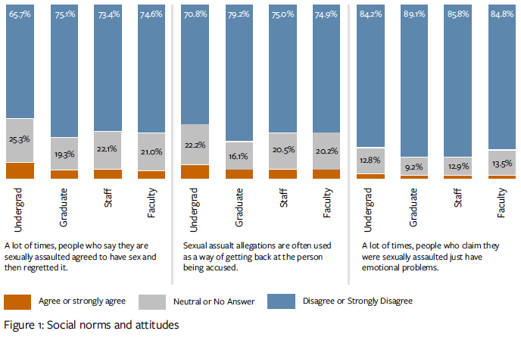

Table 4: Characteristics of perpetrators of behaviors classified as sexual assault
Perpetrators of Sexual Assault | Undergrad | Grad | Staff | Faculty
Perpetrator was a UCB undergraduate student | 66% | 12% | 8%
Perpetrator was a UCB graduate student | 3% | 36% | 2.9%
Perpetrator was a UCB staff member | 0.9% | 2% | 6%
Perpetrator was a UCB faculty member | 0.1% | 1% | 2.5% | 11%
Perpetrator was an individual not associated with UCB | 31% | 41% | 65% | 63%

4.2.2. Experiences of Harm
Primary prevention involves preventing incidents from happening before they occur. In order to carry out primary prevention effectively, it is necessary to know where and when people are being harmed. For this reason, the MyVoice survey asked participants about their experiences. An example of the resulting data is found in Table 4, which illuminates the sources of harm affecting people in our campus community, in the umbrella category of “sexual assault”. This information - in particular, the differences between the student and non-student experiences - will be useful in refining prevention and intervention efforts.
Another area on which the MyVoice survey focused was the intersection of experience of harm (SVSH) with sexual orientation, gender identity, and ethnic identity. Table 5 demonstrates that those who have identities that generally experience marginalization also report the highest rates of harmful experiences, while those with more privileged identities report the lowest. It is important to document - and understand - the disparate impact on certain communities so that prevention and response efforts are optimally tailored to their needs.

Table 5: Rank order of experiences of behaviors classified as relationship violence and sexual assault, by demographic factors
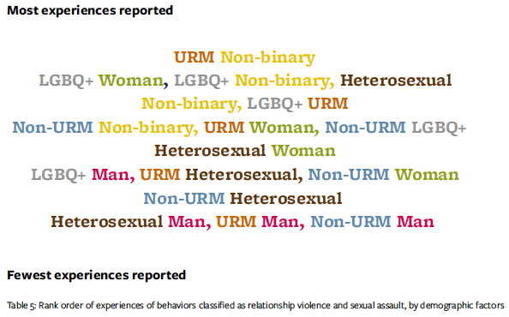

4.2.3. Resources and Reporting
An important focus of the MyVoice survey was conditions affecting a survivor’s decision to report an incident, or seek help. Every survivor has the right to choose whether or not to report harm to authorities. It is important for the campus to understand the variety of complex factors that go into this choice and to work to alleviate those factors that stem from victim blaming or fear of retaliation or other further harm. Figure 2 illustrates reasons survey participants offered for why they did not report behaviors classified in the MyVoice report as “sexual assault.”

Figure 2: Reasons participants did not tell anyone about experiences of sexual assault
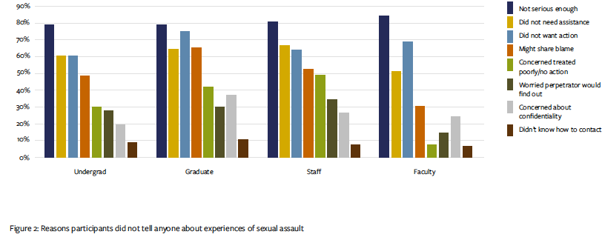
Across students, faculty, and staff, the most frequently indicated reason for not reporting was that the incident was “not serious enough”. The next most common response was that the participant did not feel like they needed assistance or wanted any action taken. The third most common reason was fear that others would think they were partly responsible for what happened to them. Information like this, while concerning, is useful in guiding campus efforts towards reducing the real and perceived negative consequences of coming forward.

4.3 Action Planning
During 2018-19, an Action Planning Team of a dozen campus leaders (students, staff and faculty) will work to digest the results in the NORC report and develop meaningful, associated action steps to improve prevention, intervention, and response to SVSH at UC Berkeley. The Action Planning Team will release its initial recommendations, along with NORC’s report, to the campus community for feedback. By the end of the Fall 2018 semester, the campus will have a final action plan, to be implemented by campus practitioners, experts, and leaders.

5.0. Prevention
UC Berkeley has adopted a comprehensive SVSH prevention strategy based on the social ecological model, recommended as an evidence-based best practice in the public health domain. This model identifies individual, relational, community, institutional, and structural levels at which work can take place; accordingly, campus prevention efforts range from individual education and peer-to-peer outreach to social norms campaigns, shifts in policy, and widespread culture change.

5.1. Mission/values
UC Berkeley takes a multi-stage, collaborative, and trauma-informed approach to implementing programs with the following aims:
- preventing sexual harassment, dating and domestic violence, sexual assault, and stalking;
- increasing awareness of rights, campus and community resources, and reporting processes;
- developing bystander intervention skills and uplifting positive social norms
Some training is mandatory, as discussed in section 5.2. Faculty and staff have annual training requirements. All incoming students must complete SVSH prevention training upon arrival. All first-time graduate student instructors have additional training requirements.
While UC Berkeley complies with state and UC mandated training requirements, it goes further in educating the campus community in bystander intervention, positive social norms, and support for survivors. Many organizations dedicate time to improving the environment of campus through educational workshops and campaigns of their own which enrich the community.
Over 20,000 people on campus received in-person prevention training in 2017-18.

5.2. Mandatory trainings
Mandatory training for students, staff and faculty complies with state, federal and UC requirements, overseen by the Title IX Officer. It varies by population, as described below.

5.2.1. Incoming Undergraduate Student Education
New student prevention is arranged using a three-stage model to engage incoming members of the Berkeley community:

Letter.
Before coming to campus, all students receive a letter from the Vice Chancellor or Dean emphasizing expectations and community standards; campus and community resources; and institutional and policies.

Online.
Students are also expected to complete a 90-minute online prevention module prior to joining the campus, which addresses several concepts including bystander intervention.

In-person.
Upon arrival on campus, students attend one of several in-person, interactive prevention sessions coordinated by a multidisciplinary team of campus partners and co-facilitated by trained staff and peers. Prevention sessions utilize a variety of teaching methods to accommodate varied learning styles and to ensure content is trauma-informed. After the performance, students participate in small group discussions led by their orientation leader. Students are required to satisfy these requirements in order to sign up for Spring classes.
95% of students completed the Bear Pack requirement (9,587 total). 94% of students completed the online requirement ‘Think About It’

5.2.2. Graduate and Professional Student Education
New graduate and professional students receive two types of sexual violence and sexual harassment prevention training, administered by a collaboration of OPHD, the PATH to Care Center, and Graduate Division. All students who begin a graduate or professional degree program after Fall 2015 are responsible for completing these requirements.

Letter.
Before arrival, all incoming graduate students receive a letter from the Dean of the Graduate Division emphasizing expectations and community standards; campus and community resources; and institutional and policies.

Online.
Pre-arrival, incoming graduate students take an online prevention training, “Think About It: Graduate Students,” developed for the UC system by Everfi. Between July 1, 2017 and June 30, 2018, approximately 4,900 graduate and professional students took the online training.

In-person.
All new graduate students also participate in an in-person prevention training program developed by the PATH to Care Center and OPHD. All incoming students had the opportunity to take these sessions during New Graduate Student Orientation, hosted by the Graduate Division. Select departments and schools also opted to incorporate the in-person prevention training into their department orientations, and worked with PATH to Care to identify and train facilitators within their own academic communities. Between July 1, 2017 and June 30, 2018, approximately 3,800 graduate and professional students participated in the in-person training.
Graduate students who participated in any type of PATH to Care-led In-Person prevention training/workshop: 2,704
Train the trainer: 27 total attendees over 2 sessions (14 graduate students & 13 staff)

First-time Graduate Student Instructors (GSIs) receive additional training in the form of a Teaching Conference sponsored by the GSI Teaching and Resource Center and the online course “Professional Standards and Ethics for GSIs,” which has a module on “Creating an Educational Environment Free of Sexual Harassment.”

5.2.3. Faculty and Staff
As required by California law (AB1825 and AB2053) and UC policy, all faculty and staff employees must complete annual prevention education training modules, starting within the first 90 days of employment. For non-represented staff, this requirement is enforced via the withholding of merit increases for those out of compliance. The majority of employees complete their training via an online module. Currently, UC Berkeley utilizes EverFi’s “Think About It” modules for both students and non-supervisory staff. For faculty and supervisory staff, modules alternate by year. A 2-hour courses is required every other year, and a shorter supplemental course is offered in the off years. The 2-hour course is provided by UCOP; the supplemental course is designed locally and features Berkeley-specific content. Multipronged efforts, including personal reminders, logistical assistance, and in-personal training alternatives are currently underway to increase participation in required training. As a result of these initiatives, compliance rates are already rising.
As of July 1, SVSH training requirement compliance was 83% for all employees and 77% for instructors

5.2.4. Greek Life
Each Greek organization affiliated with the Inter-Fraternity Council and Pan-Hellenic Council is required to have at least 80% of their chapter attend a workshop about SVSH prevention and response each semester. This is in addition to a semesterly education module about alcohol or substance abuse awareness. Both of these educational requirements are self imposed by the Greek leadership councils.

5.2.5. Athletics-NCAA
All student-athletes, coaches, and athletics staff are required by NCAA and the California State Auditor to receive annual education on sexual violence prevention, intervention and response. Currently, Intercollegiate Athletics partners with PATH to Care and OPHD to satisfy the requirements through in-person training. Content is approved by the campus Title IX Officer. The Chancellor, Athletic Director and Title IX Officer must formally attest to its completion to the NCAA. In addition to the required sessions, the PATH to Care Undergraduate Prevention Program Manager is working with select men’s teams to pilot the Coaching Boys into Men curriculum.

5.3. Educational Presentations
In addition to mandatory training, much SVSH prevention work takes the form of educational presentations which academic departments, student groups, and other units can request. Many student activists as well as administrative leaders are working to expand prevention education throughout the student experience. The hiring of a Prevention Program Manager focused on faculty and staff at the PATH to Care Center should increase opportunities for faculty and staff to get involved in prevention efforts as well.
Tailored unit-specific training workshops were provided to 7 academic departments, over 10 student, faculty, staff and administrative leadership groups, and over 1,000 service workers.

5.3.1. Health Promotion
Part of University Health Services, Health Promotion advances the health and well-being of Cal students through individual and environmental initiatives. For many years, Health Promotion housed SVSH prevention programs in collaboration with other campus units (Social Services, GenEq, others), though much of that work has since moved to the PATH to Care Center. Currently, Health Promotion programs and services touch more peripherally on SVSH.
Students are trained to work in the Sexpert Education Clinic, which provides drop-in individual education sessions on contraception, safer sex, and communication. 25 trained students reached 173 individuals through appointments and workshops in 2017-18.
1,773 students were reached through other sexual health programming:
  - Let’s Taco Bout Sex, community-based sexual health discussions with students
  - VD Chats, a sexual health video series for non-Latino identified Brown students
  - She’s Gotta Have It, a series on the intersection of Black women’s sexuality, relationships, and polyamory

5.3.2. Equity & Inclusion programs for Staff and Faculty
Through its Faculty Diversity Initiatives (for faculty) and Multicultural Education Program (for staff), the Division of Equity & Inclusion offers a number of programs aimed at creating a positive, inclusive, and respectful climate. Many of these cover prevention and bystander techniques that also serve to alleviate SVSH.
1,625 individuals received education through such programs as:
  - Workplace Diversity at Cal
  - Unconscious Bias
  - Cross Cultural Communication
  - Gender Inclusivity in Classrooms
  - Microaggressions
  - Trust and Community Building
  - Respectful Workplaces

5.3.3. PATH to Care Center Seed Grant Program
Offered by the PATH to Care Center and the Center for Support and Intervention, the Seed Grant program provides small grants to campus communities to identify and promote positive social norms related to SVSH in their communities. In 2018-19, six campus groups worked over a span of seven months to create innovative campaigns that aimed to reduce misperceptions and promote pro-social beliefs and behaviors already present in their communities. Groups that participated include: Associated Students of the University of California (ASUC); Berkeley Law; Departments of Electrical Engineering and Computer Sciences; Department of Molecular Cell Biology; University Health Services Health Workers; and University Village. These social norms programs reached around 11,400 people, including faculty, staff, undergraduate and graduate students, postgraduates, and families of students.

5.3.4. Customized PATH to Care workshops for units
A number of academic departments and service units on campus have worked individually with PATH to Care, the Gender Equity Resource Center, the SVSH Advisor, Equity and Inclusion, OPHD and others to receive additional in-person educational presentations. These sessions, usually initiated by leadership within an academic department or staffing unit, are tailored to the specific needs of the organization. Educational presentations within intact communities, such as academic departments, have been found to be more effective in creating behavior and norm change. 18 departments/offices received individualized presentations, the majority from PATH to Care Center specialists.

6.0. Survivor Support
UC Berkeley’s administration, staff, students, and faculty strive to create an environment that is supportive and safe for survivors of violence and harassment. An important aspect of this effort involves providing trauma-informed resources, specialists, and advocates who empower survivors to choose a path forward that serves their needs.

6.1. Mission/values
Violence, trauma, and related impacts may affect an individual’s well-being, professional and educational pursuits, as well as the overall climate of an organization. Ensuring a climate of support for survivors is critical to creating a culture of inclusion and enabling each member of the 56,000-person UC Berkeley community to reach their fullest potential.
Over the last few years, staffing has increased dramatically at PATH to Care and Social Services; so has the demand for these services. Other centers, like the Gender Equity Resource Center and the Multicultural Community Center, support survivors in less formalized ways.

6.2. PATH to Care Center
Confidential advocates at the PATH to Care Center provide affirming, empowering, and confidential support for survivors and those who have experienced domestic and dating violence, sexual assault, sexual harassment, stalking, and related crimes and incidents. Confidential advocates bring a non-judgmental, caring approach to exploring all options, rights, and resources. As one of few Confidential Resources on campus, PATH to Care is often the first call a survivor makes. Those who are supporting survivors can also call PATH to Care for guidance. Additionally, the PATH to Care Center offers trainings to first-responders, assists in protocol development, and general improvement of response services. In order to address the needs of culturally specific or underserved populations, PATH to Care offers alternative healing modalities, works within impacted communities, and offers identity based groups.

6.2.1. Care Line
The Care Line is a 24/7 hotline that supports those who have been impacted by sexual violence and harassment and those who are supporting people who have been impacted. It is designed to assist those in crisis or in need of immediate support. During business hours, the PATH to Care Center’s confidential advocates answer the line directly. After hours, the Care Line is answered by Bay Area Women Against Rape (BAWAR)’s advocates. When a BAWAR advocate is made aware that the caller is a member of the UC Berkeley community and in need of immediate assistance, they connect the caller directly to an advocate from the PATH to Care Center. During a Care Line call, a crisis assessment is done to determine if a phone session in the moment or if scheduling an appointment is more appropriate. Priority is always given to immediate safety planning and accompaniments to emergency medical attention or urgent reporting to police. The Care Line is also frequently used by faculty and staff members when a student is disclosing to them. The advocate on call will walk them through how to best support the individual disclosing as well as any reporting obligations they may have.

6.2.2. Survivor support services
- PATH to Care offers a number of distinct services, in addition to the 24/7 Care Line.
- Advocacy services are types of support a survivor may need in order to continue working, living or learning on campus. This support can include, but is not limited to, academic or housing accomodations, assistance finding therapy, assistance in exploring whether or not to report, emotional regulation tools, and much more.
- Accompaniments are a specific type of service in which an advocate accompanies and supports a survivor who is seeking emergency medical care, reporting to the police or university, participating in evidence collection or testifying in a trial, or in other situations in which an individual wants the support of an advocate at their side. Accompaniments are sometimes scheduled, but often advocates have little to no warning of when this service will be needed.
- Healing: A variety of healing modalities are available via the PATH to Care Center, including Trauma Release Exercises, Resilience Toolkit, Yoga as Healing, healing circles, and tailored healing services for an impacted community. As an example, Yoga As Healing is a series created to allow those impacted by sexual and relationship violence, stalking, and sexual harassment to re-establish a sense of comfort within their physical bodies.

6.2.3. Responder Consult, Protocols, and Trainings
PATH to Care advocates also offers consultations, assistance with protocol development, and ‘first-line responder’ training to others on campus. These consults and training equip all, including those most likely to receive disclosures, with the tools to make survivors feel heard and supported, connect survivors to the appropriate resources, and fulfill their own Responsible Employee reporting obligations. 262 campus community members participated in PATH to Care’s Prevention and Response Introductory workshop, over 11 sessions.
Despite the continued expansion of advocacy and prevention programs developed by the PATH to Care Center, the need continues to grow as the national landscape begins to address the prevalence of these issues. As more of the campus community becomes aware of the services offered by PATH to Care, the more requests come in for survivor support and community training. Services provided in 2017-18:
- 315 Individual clients
- 116 Accompaniments
- 2,860 distinct survivor support services
- 30 Yoga as healing classes
The volume of CARE line calls is not documented for 2017-18, due to technical challenges. A new system has been installed that should allow the call volume to be quantified in future years.

6.3. Social Services
The Social Services Counseling unit at UHS is a Confidential Resource offering supportive, non-judgmental counseling, resources and referral information. They specialize in supporting students who are coping with specific types of issues, including sexual assault, rape, harassment, stalking, and intimate partner or dating violence. Social Services is not designed to do long term counseling, and facilitates warm referrals out to practitioners in the community in many cases.
Social Services and PATH to Care both work with campus survivors to provide the support they need. Their goals are similar but core missions differ. The organizations work closely together and will refer those in need to one another. Typically, a survivor will go to Social Services for emotional processing/therapy, whereas PATh to Care advocates help the survivor navigate campus structures to receive the long term help they need and create a living, working, and learning environment in which the trauma is most tolerable.
The Social Services staff working with sexual violence issues has seen an immense increase in demand and utilization of services (see Table 6). This increase has led to wait times for clients and challenges for staff, who see many clients per day. Social Services also offers support for clients who are respondents or have concerns that they may have caused harm; these ‘respondent’ visits have been fairly steady, while visits by survivors have increased greatly. In 2017-18, Social Services provided 1,137.5 hours in individual appointments and 88.5 hours in group sessions.

Table 6: Utilization of Social Services, last four academic years
Fiscal Year | SVSH Survivor Appointments | SVSH Survivor Clients | SVSH Respondent Clients | SVSH Respondent Appointments | Total Appointments | Total Clients
2014-15 | 357 | 132 | N/A | N/A | 357 | 132
2015-16 | 436 | 120 | 15 | 35 | 451 | 135
2016-17 | 947 | 194 | 10 | 20 | 967 | 204
2017-18 | 1128 | 251 | 16 | 34 | 1162 | 267

6.4. Employee Assistance
Be Well at Work - Employee Assistance (formerly known as Care Services, but not to be confused with the PATH to Care Center) provides no-cost confidential counseling and referrals for UC Berkeley faculty and staff. The focus of Employee Assistance includes but is not limited to: mental illness, chemical dependency, interpersonal problems, employee deaths, threats of violence, work stress, and change management. While Employee Assistance does not, like Social Services, specialize in the trauma of sexual violence, they are a Confidential Resource and can offer counseling or guidance to faculty and staff who seek it, as well as consultation services for managers who are dealing with the effects of an SVSH-related situation in their workplace.
In 2017-18, Employee Assistance worked with 19 individual clients (73 contacts, 31 sessions, 25 referrals) and provided 14 consultations on 6 cases.

7.0. Investigation and Adjudication
The formal campus system for responding to allegations of SVSH misconduct starts from the point at which an allegation is reported to the Title IX office. This section covers the investigation process as well as the subsequent adjudication and disciplinary processes for cases with student, faculty, and staff respondents. It discusses the preventive and protective interim measures that can be taken, as well as the various types of resolutions that are possible.

7.1. Mission/values/principles statement
UC Berkeley is committed to creating and maintaining a community dedicated to the advancement, application and transmission of knowledge and creative endeavors through academic excellence, where all individuals who participate in University programs and activities can work and learn together in an atmosphere free of harassment, exploitation, or intimidation. To this end, every member of the community should be aware that the University prohibits sexual violence and sexual harassment, retaliation, and other behavior that violates law and/or University policy. The processes for investigating and disciplining SVSH misconduct should be transparent, fair, trauma-informed, and consistent.

7.2. University of California Policy on Sexual Violence and Sexual Harassment
The formal campus response to SVSH misconduct is guided by the systemwide UC Policy on Sexual Violence and Sexual Harassment (“SVSH Policy”). Last revised in 2016, the SVSH Policy is available at policy.ucop.edu/doc/4000385/SVSH. (The policy is due to be revised again in 2019.)
The SVSH Policy defines types of conduct that are prohibited (“Prohibited Conduct”), including sexual assault, sexual harassment, dating and domestic violence, stalking, and retaliation. The SVSH Policy requires the University to respond promptly to reports of Prohibited Conduct and take appropriate action to prevent, to correct, and, when appropriate, to impose disciplinary sanctions for behavior that violates this Policy. Berkeley’s own local implementation procedures for enforcing the Policy are available at ophd.berkeley.edu/policies-and-procedures.
On the Berkeley campus, compliance with the SVSH Policy is enforced by the campus Title IX officer, who is also the director of the Office for Prevention of Harassment and Discrimination (OPHD).

7.3. Reporting, Investigation and adjudication (discipline) processes - overview
It is every survivor’s choice whether or not to make a report to OPHD. Some survivors choose to report experiences of harm right away; others may wait a significant amount of time, or may never report. This section discusses the formal process that ensues when a survivor does report to OPHD, or when a third party reports an incident that they learn about. OPHD determines whether policy has been violated; it does not impose discipline. The latter is the responsibility of other campus authorities and administrative units (see section 7.4).

“The University’s student disciplinary procedures emphasize education, personal growth, accountability, and ethical behavior -- upholding standards of responsible conduct to balance the interests of the University community and the student. When formal fact-finding procedures are used, the procedures are designed to provide a prompt, fair, and impartial resolution of the matter.” --Code of Student Conduct

7.3.1. Reporting, initial assessment, and interim measures; Responsible Employee obligations
“Reporting” refers to notifying OPHD of potential misconduct. OPHD is the office that investigates reports of SVSH misconduct regardless of whether the person impacted by the conduct - “complainant,” in the terms of the SVSH Policy - is a student (sa.berkeley. edu/conduct/sexual-misconduct-policy), staff (ophd.berkeley.edu/policies-and-procedures/staff), faculty member (ophd.berkeley.edu/ policies-and-procedures/staff), or member of the community; and regardless of whether the accused, or “respondent,” is student, staff
or faculty. OPHD investigators (“Complaint Resolution Officers”) have specialized training and most have legal backgrounds. Their procedures are tightly governed by federal (Title IX)(www2.ed.gov/about/offices/list/ocr/docs/tix_dis.html), state and UC systemwide regulations.
A complainant may contact OPHD directly, or a third party - a witness, or someone in whom the survivor has confided - may do so. All UC Berkeley employees are required by the ‘Responsible Employee’ clause of the UC SVSH Policy to report alleged misconduct affecting a UC Berkeley student. Instructors and supervisory staff have an additional requirement to report misconduct affecting any member of the UC Berkeley community, if they learn about the misconduct in the scope of their employment.
Upon receiving a report of a potential SVSH policy violation, OPHD will reach out to the complainant to ensure that they are safe; refer them to on and off-campus resources, including PATH to Care, a Confidential Resource (see section 7.2); and invite them to schedule an intake meeting with a Complaint Resolution Officer. OPHD may propose and implement interim measures, intended to ensure a complainant’s safety and ability to work or study while simultaneously avoiding penalizing a respondent; these can include no-contact directives, academic accommodations, emergency housing, interim suspension, or other measures suited to the situation.
The Responsible Employee rule differs from mandated reporting laws such as the California Child Abuse and Neglect Reporting Act (CANRA), a state law that requires certain University employees to report known or suspected child abuse or neglect. UC Berkeley faculty members are not generally considered Mandated Reporters under CANRA, even when students under the age of 18 enroll in their classes. Exceptions include faculty who are health professionals,
faculty whose university duties require direct contact with and supervision of children, etc.

7.3.2. Resolution types
There are several possible outcomes after a report has been made to OPHD. Whether a case is resolved informally with preventative measures, formally investigated, or administratively closed for lack of evidence, depends on a number of factors, including the wishes of the complainant and respondent.

7.3.2.1. Alternative Resolution
Informal or “Alternative Resolution” is an option in which measures are taken to address the situation that led to a report and prevent it from continuing or worsening. Alternative Resolution does not involve a formal investigation or a finding of whether or not the UC SVSH Policy was violated; thus it does not lead to formal disciplinary action. To proceed to Alternative Resolution, both the complainant and respondent must agree that the complaint should be resolved without a formal investigation. Situations which pose a threat to the campus community may not be suitable for Alternative Resolution. Alternative Resolutions could involve space- sharing agreements, no-contact directives, work reassignments, counseling for one or both parties, or other solutions tailored to the particular situation. Alternative Resolutions are documented outcomes, often with provisions that are enforced over a period
of time.

7.3.2.2. Formal investigation
If the allegations of misconduct, if true, would amount to a policy violation, if there is enough evidence to proceed, and if both parties have not expressed a preference for Alternative Resolution, OPHD launches a formal fact-finding investigation. This involves interviewing witnesses, collecting documentary evidence, making findings of fact and analyzing those facts against policy standards in a written report, to which both parties have a chance to respond before it’s finalized. If the OPHD investigation results in a finding, by a preponderance of the evidence, that misconduct has occurred, the case passes to campus adjudicators for discipline (see section 7.4). The preponderance of evidence standard means that it is more likely than not that an event occurred.

7.3.2.3. Administrative closure
Sometimes a complainant doesn’t wish to pursue either kind of resolution process with OPHD, or a third party makes a report but doesn’t know the names of the parties. Under circumstances like these, OPHD typically has limited ability to address the issue. When the survivor’s identity is known, OPHD makes multiple efforts to reach out, provide resources, and offer options to go forward with the process. Outside observers who know that something happened may wonder why OPHD is not taking action, but OPHD is not able to discuss the matter with non-involved parties. Importantly, the complainant and respondent also have rights to privacy. Sometimes, allegations of misconduct are reported to OPHD which, while problematic, would not violate the SVSH policy. Sometimes OPHD can recommend and implement preventive measures to address the situation, such as departmental trainings, but cannot take it to the level of a formal investigation. There are also instances where another policy violation may be at issue, and OPHD will refer the complaints to another appropriate campus office, e.g., Human Resources, Academic Personnel, or the Center for Student Conduct. When OPHD cannot move forward in a situation of any of these kinds, the matter is termed ‘administratively closed,’ although records are retained, and the matter can be re-opened in the future if additional information that enables further review under the SVSH Policy emerges.

7.4. Adjudication and discipline phases
For longstanding historical reasons, the adjudication processes for faculty, students and staff are independent, carried out by different bodies and following different procedures. If a student is the respondent (the accused), the disciplinary case is
handled by the Center for Student Conduct. If a faculty member is the respondent, the disciplinary case is handled by the Vice Provost for the Faculty. If a staff member is the respondent, the disciplinary case is handled within Human Resources.
The campus aspires to take consistent disciplinary steps regardless of who has committed and who has reported the misconduct. However, differences in the appointment status of students and types of employees make this challenging to accomplish in a simple and transparent way. There is still work to do to create the perception - and reality - of consistency in this area.

7.4.1. Student respondents
When OPHD has completed its investigation of a case involving a student respondent, OPHD sends its report and its recommendation regarding whether there has been a violation of the UC Policy on SVSH and Code of Student Conduct, to the Center for Student Conduct (CSC) (sa.berkeley.edu/conduct/sexual-misconduct-policy). CSC reviews the report, determines whether it agrees with OPHD’s recommendations, and decides whether to impose a sanction. Student sexual assault cases are subject to mandatory minimum sanctions of two years. Factors such as the use of force or causing incapacitation may lead to a more serious sanction. The complainant and respondent may offer comments on the investigator’s recommendations and potential sanctioning. After the responsibility and sanction decisions are made, the complainant and respondent both have the right to appeal the decision to an Appeal Hearing Officer. Appeals must be based on specific procedural grounds. For a detailed description of the student adjudication process, see sa.berkeley.edu/sites/default/files/FINAL%20Adjudication%20Model%2012.18.15%20%284%29. pdf?dialogFeatures=protocol=http.

7.4.2. Staff respondents
When OPHD has completed an investigation into allegations of SVSH misconduct by a staff respondent, the OPHD report goes to the respondent’s supervisor (or other appropriate administrative authority). Both parties (complainant and respondent) have the right to provide a written response to the OPHD report. The respondent’s supervisor (or appropriate administrative authority) has the responsibility to propose and implement disciplinary action. The proposed discipline must be reviewed by the Chief Human Resources Officer, who may approve the proposed discipline or ask for revisions to it. A supervisor could recommend formal corrective action, up to and including termination, or remedial actions that do not amount to formal correction. Following approval of the proposed disciplinary response by the Chief Human Resources Officer (CHRO), the respondent’s supervisor implements the approved decision. Policies governing sanctions for staff can be found in PPSM-62, PPSM-64 and PPSM-70. For a detailed description of the staff adjudication process, see ophd.berkeley.edu/sites/default/files/ local_staff_adjudication_model.pdf.

7.4.3. Non-faculty academic personnel
When OPHD has completed an investigation into allegations of SVSH misconduct by a non-faculty academic appointee, OPHD provides its report both to the respondent’s supervisor or other appropriate administrative authority and to the Vice Provost for the Faculty. Both parties (complainant and respondent) have the right to provide the Vice Provost with a written response to the OPHD report. The respondent’s supervisor (or appropriate administrative authority) has the responsibility for proposing and implementing a response, which could consist of informal resolution or corrective action or other discipline. The Vice Provost for the Faculty must approve the proposed response, or ask for revisions, before it is implemented. For a detailed description of the non-Senate faculty adjudication process, see ophd.berkeley.edu/sites/default/files/ local_non_faculty_academic_personnel_adjudication_model.pdf.

7.4.4.Faculty respondents
Berkeley has many kinds of instructors. Senate faculty, or ladder-rank faculty, are those on the tenure track; they include Assistant Professors, Associate Professors, full Professors, and emeriti. A number of campus instructors are in adjunct positions or have the Lecturer title.
As of April 2018, Berkeley has 1,490 active ladder-rank faculty (Source: CalAnswers).
As of April 2018, Berkeley has 946 active lecturers (Source: CalAnswers).
Faculty are held to the standards of the Faculty Code of Conduct, found in section 015 (www.ucop.edu/academic-personnel-programs/_files/apm/apm-015-and-016-issuance1/ apm-015-7-1-17.pdf) of the systemwide Academic Personnel Manual (APM). An OPHD finding that the UC Policy on SVSH has been violated constitutes probable cause
of a violation of the Faculty Code. Though the Faculty Code pertains to all faculty, disciplinary procedures for Senate faculty differ in some ways from those for non-Senate faculty.

7.4.4.1. Senate faculty
When OPHD has completed an investigation of allegations of SVSH misconduct by a Senate faculty respondent, the OPHD report goes to the Vice Provost for the Faculty, who is responsible for the adjudication and discipline of faculty misconduct. If OPHD has made findings of an SVSH policy violation by a Senate faculty member, the Vice Provost consults with a campus Peer Review Committee on the appropriate response. There are two main options: file formal disciplinary charges with the campus Privilege and Tenure Committee, as outlined in APM-016; or reach a negotiated settlement with the faculty member. Formal discipline of a Senate faculty member can be imposed only after the Privilege and Tenure Committee has conducted a hearing and recommended one (or more than one, or none) of the six possible formal sanctions that APM-016 permits (written censure, reduction in salary, demotion, suspension, denial or curtailment of emeritus status, and dismissal from the employ of the University). The Privilege and Tenure Committee makes its recommendation to the Chancellor, who then makes a final decision. (Certain sanctions require approval by the Regents or the University President.) Negotiated settlements are an alternative to the Privilege and Tenure process. A settlement could include such outcomes as resignation, retirement with restrictions, restrictions on the use of campus space, and many others. Settlement agreements often include mutually agreed upon public statements that inform the community about the outcome of a case. For a detailed description of the Senate faculty adjudication process, see ophd.berkeley.edu/sites/default/files/local_faculty_adjudication_ model.pdf.

7.4.4.2. Non-Senate non-represented faculty
Upon receiving an OPHD report regarding a non-Senate, non-represented faculty respondent (for example, an adjunct or acting professor), the Vice Provost for the Faculty consults with the Academic Personnel Office on the appropriate response. APM-150 provides two main options: Informal Resolution, which take the form of corrective or remedial measures; or more formal corrective action, of which there are five types: written censure, suspension without pay, reduction in salary, demotion, dismissal. For a detailed description of the non-Senate faculty adjudication process, see ophd.berkeley.edu/sites/default/files/local_nonsenate_adjudication_model.pdf.

7.4.4.3. Lecturers
For lecturers, who are represented by a union, the supervisor must issue a written notice of intent both to the employee and the union before proceeding with formal discipline (suspension, reduction in pay, dismissal). The employee has 14 days to respond before a final decision is communicated; final discipline must be communicated within 30 days of the written notice of intent, and may not be more severe than what the notice of intent describes. Represented employees may grieve and/or seek arbitration of disciplinary actions.
Represented faculty have the option to grieve dismissal via the Academic Senate. For more information, see ucnet.universityofcalifornia.edu/labor/bargaining-units/ix/docs/ix_2011-2015_30_discipline-dismissal.pdf.

7.4.4.4. Senior leaders
In 2016, President Napolitano created a Systemwide Peer Review Committee (sexualviolence.universityofcalifornia.edu/files/documents/uc- community-peer-review-cmte.031816.pdf) that must approve proposed disciplinary sanctions in SVSH misconduct cases involving faculty or staff who occupy positions of senior leadership. Senior leaders include, but are not limited to, Chancellors, Associate and Assistant Chancellors, Provosts and Vice Provosts, deans, coaches, and Athletic Directors. The systemwide review process aims to promote equity and consistency in adjudications of those who may hold power on campus.

7.5. Consistency
In 2017, the Chancellor’s Joint Administration/Senate Committee on SVSH (chancellor.berkeley.edu/sites/default/files/svsh_full_
report_1-31-2017.pdf) identified ‘horizontal equity’ as a goal for the campus adjudication response to student, staff and faculty SVSH cases. This refers to the ambition of providing a consistent sanction for conduct regardless of the status of the respondent. It is challenging to achieve given the independence of the various adjudication systems for these groups, for whom there are different disciplinary codes, options, and terms of employment. Building in additional levels of review - e.g., for staff, the CHRO; and for faculty, the Peer Review Committee - is intended to help ensure a consistent overall approach. A concern often voiced by the community is that the campus responds more severely to staff misconduct than to faculty misconduct, and that the campus protects its star faculty. Existing policies do indeed make it more laborious to dismiss Senate faculty than to dismiss staff. However, the campus is committed to a fair process that is not influenced by prestige. The California State Audit report concluded that faculty prestige did not correlate with disciplinary outcomes in its review of faculty disciplinary cases between 2012-2015.

7.6. Time to completion
The time it takes to resolve a case, from the first report of allegations through the imposition of sanctions, can be lengthy, especially so for cases with faculty respondents. While fair and thorough investigation as well as conscientious implementation of due process is inevitably time-consuming, the long duration of many cases has been a concern in the community and a subject of scrutiny by outside investigators (see section 3.3.6). In general, the length of a case correlates with the number of steps it involves. Investigations in which new information continues to emerge take longer than cases where the facts are all available at the outset.
Adjudication tends to take longer for faculty than for staff or students, because of the number of potential steps in the process. In response to concerns over long durations, various systemwide policies and procedures have established timelines for certain elements of the process. Some of these are more aspirational than realistic.

7.6.1. OPHD investigation timeline
An example of an aspirational timeline is seen in the 2017 systemwide implementation procedures for the SVSH Policy, which give Title IX offices 60 business days to complete an investigation and determine whether or not the SVSH policy has been violated. Given current policy requirements and staffing levels, this is an unrealistic goal for OPHD, and results in frequent requests for extension. (As discussed in section 8.4, OPHD handled 446 incoming cases in 2017-18, and had a maximum of 6 complaint resolution officers (investigators) on staff at any given time). OPHD records show that the time from an initial report to a completed investigation report varies greatly, depending on the level of complexity of the case. Between July 1, 2017 – June 30, 2018, the average time to completion for cases that went through formal investigations was 146 business days, with a median of 124. Alternative resolutions are usually a simpler process, though negotiations can be lengthy and complex as well. In 2017-18, the average time to completion for alternative resolutions was 45 business days; the median was 27.
The phases of the OPHD process are depicted below:

Figure 3: OPHD process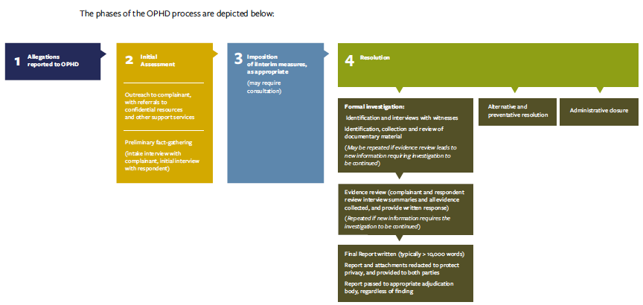
Phase 1: Allegations reported to OPHD
Phase 2: Initial Assessment
- Outreach to complainant,with referrals to confidential resources and other support services
- Preliminary fact-gathering (intake interview with complainant, initial interview with respondent)
Phase 3: Imposition of interim measures, as appropriate (may require consultation)
Phase 4: Resolution
- Formal investigation: Identification and interviews with witnesses
  - Identification, collection and review of documentary material (May be repeated if evidence review leads to new information requiring investigation to be continued)
  - Evidence review (complainant and respondent review interview summaries and all evidence collected, and provide written response) (Repeated if new information requires the investigation to be continued)
  - Final Report written (typically > 10,000 words). Report and attachments redacted to protect privacy, and provided to both parties. Report passed to appropriate adjudication body, regardless of finding.
- Alternative and preventative resolution
- Administrative Closure

7.6.2. Faculty adjudication timeline
The adjudication timeline for faculty cases has also been the subject of considerable concern. Progress was made in 2017 when new systemwide procedures eliminated a potentially lengthy faculty investigator phase, replacing it with a more efficient Peer Review Committee stage. Despite this change, however, the process is inevitably time-consuming because of its many steps, designed to ensure fair and careful review in a system of shared faculty governance. A simplified flowchart for a faculty disciplinary case, which does not include the extra stages of oversight review required in case the respondent holds a senior administrative role, is shown below:

Figure 4: Senate faculty investigation and adjudication phases
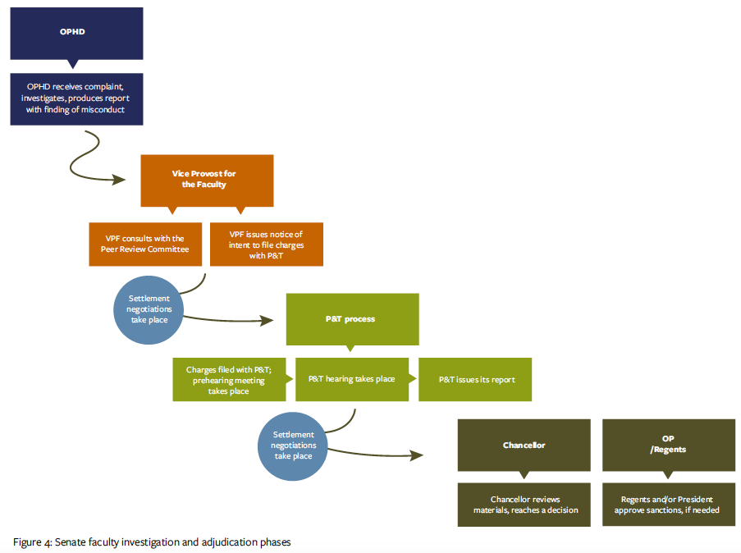

7.6.3. The ‘three-year rule’
Much attention has been paid to the ‘three-year’ rule for faculty respondent cases. This clause in APM-016 was reformulated in 2017 to make clear its function as an imperative to act promptly whenever an allegation is made:
“The Chancellor must initiate related disciplinary action by delivering notice of proposed action to the respondent no later than three years after the Chancellor is deemed to have known about the alleged violation.” [APM-016]
There is no statute of limitations for SVSH cases on campus. Anyone can make a report to OPHD at any time. Provided that evidence is still available and the respondent is still affiliated with UC Berkeley, OPHD follows the same investigative and adjudicative proceedings regardless of when the incident of alleged harm occurred, applying the policies that were in force at the time the incident is alleged to have occurred.

7.7. Databases and pattern tracking
OPHD retains data on allegations and their outcomes. Recently, OPHD adopted the Advocate GME database platform as a case management tool. This makes it possible to track some patterns over time and determine whether a newly reported incident is part of a broader pattern. Previously, records were kept, but not digitized, making the analysis of longitudinal patterns more challenging.

7.8. Privacy, confidentiality and transparency
One of the complicated aspects of any discussion of SVSH on a university campus is that privacy considerations and confidentiality requirements, from state employment law to federal privacy rights regarding student records, generally make it impossible for the university to discuss individual cases, even though the community naturally wants to understand how and why a decision was reached. When the campus cites privacy considerations in response to inquiries, it can be perceived as a lack of transparency.
But it is critically important to parties in past and current cases — and to parties in potential future cases — to know that the university will keep their protected personal details confidential. Sometimes parties choose to share some or all of what has happened; sometimes they do not. This choice must remain their own to make. The best the campus can do in such situations is explain the general process that it follows.
Under certain circumstances, such as dismissal of an employee, the campus does make a public statement when a case is resolved, though does not typically reveal details of the investigation. As a public institution, some campus records are accessible to the public via the Public Records Act process.

8.0. Multiple lenses on the experience of SVSH on campus
This section provides data from a variety of perspectives, each of which sheds light on the range and impact of SVSH experiences in the campus community. Reports to OPHD and UCPD are one lens for assessing how often, to whom, and where, incidents of SVSH are occurring. However, national studies generally agree that only a minority of survivors report sexual assault to authorities. A more inferential lens onto SVSH incidence on campus is provided by the use of campus resources such as PATH to Care or Social Services. A third lens is self-report, through the anonymous MyVoice Survey.
A challenge in quantifying any aspect of SVSH, including such important questions as how often experiences of harm are reported to offices that track such things, is that terms such as “sexual harassment” and “sexual assault” mean different things to different people. Another is that data are collected over different time periods. Both of these dimensions of difference are at play in the different data sources that we cover here.
We begin with the results of MyVoice survey, in which members of the campus community provided confidential, direct answers to questions about their own experiences within the last five years (or since coming to Berkeley).

8.1. MyVoice Incident Rates
In asking the campus community about their experience, the MyVoice survey avoided general terms such as “sexual harassment” or “sexual assault,” which different users might interpret differently. Rather, it asked participants a series of specific behavioral questions which NORC, in its subsequent report of survey results, aggregated into four overarching categories of harm - sexual harassment, sexual assault, dating and domestic violence, and stalking. As an illustration, the behavior-based questions aggregated for analysis purposes into the descriptive category of “sexual assault” are given below. Individuals were asked about these specific behaviors, not whether they had experienced sexual assault.

Table 7: Behavior-based questions in the aggregate category of “sexual assault”
Survey Questions Classified as Experiences Related to Sexual Assault | Percentage answering ‘yes’ (all survey participants)
Someone attempted to fondle, kiss, or rub up against the private areas of your body (lips, breast/chest, crotch or butt) or remove some of your clothes without your consent (but did not attempt any sexual penetration). | 8.7%
Someone fondled, kissed, or rubbed up against the private areas of your body (lips, breast/chest, crotch or butt) or removed some of your clothes without your consent (but did not attempt any sexual penetration). | 6.7%
Someone attempted to put their penis, fingers, or other objects into your vagina and/or butt without your consent, and/or attempted to have oral sex with you without your consent. | 2.2%
Someone put their penis, fingers, or other objects into your vagina and/or butt without your consent, and/or had oral sex with you without your consent. | 1.9%
Someone recorded, photographed, transmitted or distributed intimate or sexual images of you without your knowledge and/or consent. | 1%
As seen in the figure below, undergraduates reported the highest rate of SVSH incidence overall; nearly 17% reporting experiences that, in the terms of the survey, fell into the category of sexual assault, while nearly 30% reported experiencing behaviors in the sexual harassment category. Incidence rates of SVSH were lowest overall for staff and faculty.

Figure 5: Experiences of Different Forms of Harm, by Affiliate Group
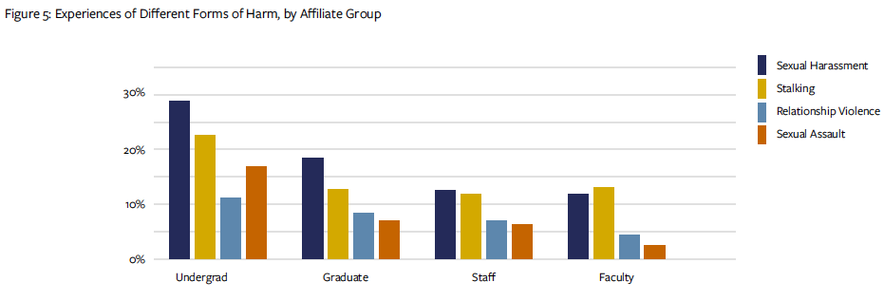
MyVoice was designed to uncover the depth and range of impact that SVSH has had on the campus community, in order to inform prevention efforts on campus. As the figure below indicates, the locations of reported experiences aggregated into the category of ‘sexual harassment’ varied considerably across groups. For undergraduates, the majority of such experiences occurred off-campus, while for staff and faculty, the majority of such experiences occurred in their on-campus workplaces.

Figure 6: Locations of Experiences of Harassment by Affiliate Group
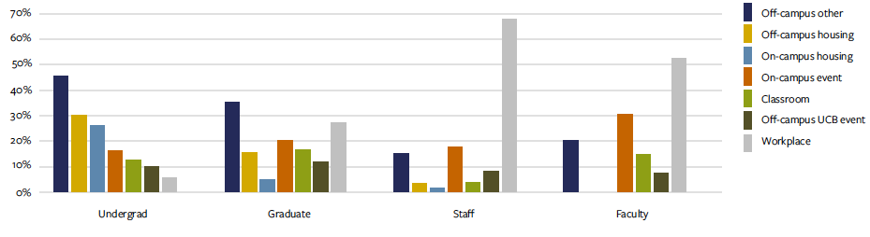Knowing where community members are most likely to experience harm is helpful in tailoring prevention training to these areas.

8.2. Survivor Support Utilization
Utilization of confidential survivor support services, of which the campus has several (see section 6), is an indicator not only of the experience of harm on campus but also of the ability of campus resources to provide support.
In 2017-18, PATH to Care provided advocacy for 315 individual clients affected by SVSH. Social Services provided counseling to 251 students (including 62 referrals from PATH to Care), and Employee Assistance provided care to 19 employees, supporting them in dealing with the impact of SVSH. It is safe to assume that over 500 individuals sought help from confidential resources on campus in 2017-18 with issues relating to sexual violence and harassment.

8.3. UCPD reports
Universities are required by the Clery Act to provide an annual summary of student incidents of sexual violence that are reported to campus authorities, including law enforcement. A full accounting can be found in the Clery Campus Fire and Safety Report, which provides calendar year data.
(See ucpd.berkeley.edu/sites/default/files/uc-berkeley-annual-fire-safety-security-report.pdf) In 2017-18, UCPD received 66 reports of sexual assault, relationship violence, and stalking:
Members of the campus community have the option to report incidents of sexual violence to law enforcement - whether UCPD or local community police departments - or the campus Title IX office, or both. As seen in the next section, reports to OPHD are more numerous than reports to UCPD.

Table 8: reports received by UCPD in 2017-18
Type of offense | Number of offenses reported
Sexual Assault | 36
Domestic violence/dating violence | 16
Stalking | 24

8.4. OPHD investigations
The caseload at OPHD provides a lens onto SVSH prevalence on campus. Since January 2018, OPHD has been using a new database that makes data easier to track. This database shows that the number of incoming cases has continued to outpace the number of cases closed.
Incoming allegations and cases closed, OPHD, January-June 2018

Figure 7: Incoming allegations and cases closed, OPHD
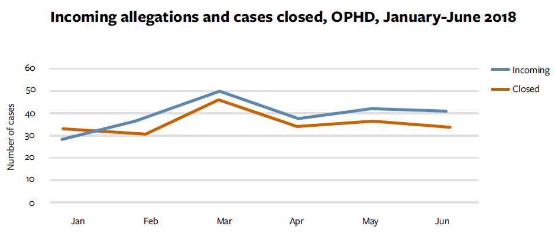

We explore here the profile of OPHD cases in 2017-18 and the nature of their outcomes.

8.4.1. OPHD allegations received
As discussed in section 7.3, OPHD receives reports of conduct that implicates the UC Policy on SVSH or campus policies against discrimination. The jurisdiction of OPHD is the campus, or behavior by those representing the campus.

Figure 8: allegations reported to OPHD, by type
(“Dis/Ha” = Discrimintation or Harassment)
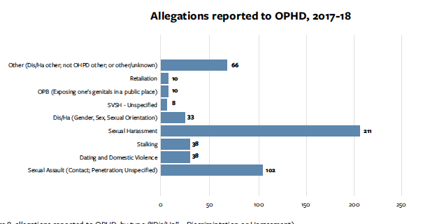
In 2017-18, OPHD received 446 reports, which included 516 allegations.
The largest subcategory of SVSH-related allegations (211) was sexual harassment. There were 102 allegations of sexual assault and 38 of dating and domestic violence.
As Figure 9 illustrates, for the 446 reports made in 2017-18, many more reports to OPHD came from third party ‘Responsible Employees’ than from complainants directly. The “Other” category includes third parties who are not identified Responsible Employees (e.g. students without reporting obligations; non-affiliates; or anonymous).
By a sizable majority, the biggest fraction of complainants (73%) and respondents (35%) were students (Figure 10). (‘Complainant’ refers to the impacted person, regardless of who reported the incident to OPHD; ‘respondent’ refers to the person accused of harm.) Many factors contribute to this ratio including, the sheer number of students on campus (30,574, in Fall 2017); the fact that Responsible Employees have a special obligation to report possible harm done to students (section 7.3.1); and higher rates of violence among students, as also shown by MyVoice survey results (section 8.1). For respondents, ‘Other’ is also a large category; this refers to individuals who are not affiliated with the university or whose identities are unknown.

Figure 9: Source of information for allegations received by OPHD in 2017-2018 (447 reports)
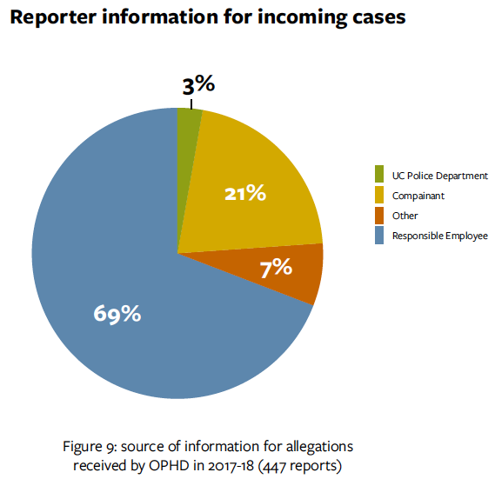

Figure 10: Incoming allegations to OPHD, by party affiliation
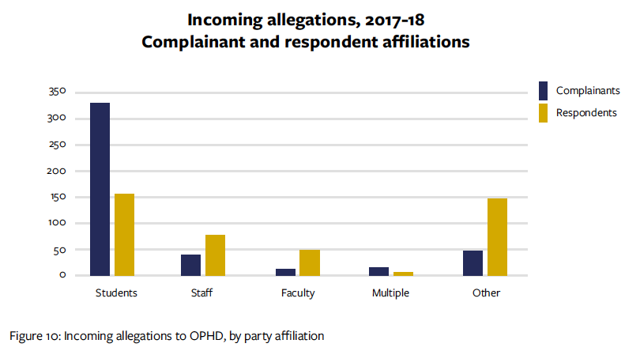

8.5. Outcomes of investigation and adjudication
Another perspective on prevalence rates of SVSH on UC Berkeley’s campus is provided by resolutions of matters once they have been reported. While the outcome of any individual case is confidential, overall numbers are useful in assessing the degree to which the campus is able to hold community members accountable. This section illustrates the final outcomes of SVSH cases that came through OPHD. (Note that this section does not include reports made to law enforcement.)

8.5.1. Cases closed by OPHD
In 2017-18 OPHD closed 380 cases, involving allegations of discrimination, sexual harassment, sexual violence, and other prohibited behavior, as well as allegations which were uncertain or were ultimately handled by another department (Figure 11).
The charts on this page demonstrate the affiliations of respondents and complainants of all cases closed by OPHD in 2017-18. Paralleling the distribution of incoming allegations, students outnumbered staff and faculty by a large margin.
As seen in Figure 12, 14% of cases closed by OPHD went through formal investigation; 9% were resolved through Alternative Resolutions. The majority of cases closed by OPHD were administratively closed, a process that involves contacting parties, providing resources, conducting an initial assessment of the allegations, and potentially recommending and implementing preventive measures (see section 7.3.2.3). Note that the category of “Administratively closed; preventative measures” is a new classification. Such outcomes used to be grouped with Alternative Resolutions. Since January 2018 they have been classified separately.)

Figure 11: Cases closed by OPHD, by party affiliation
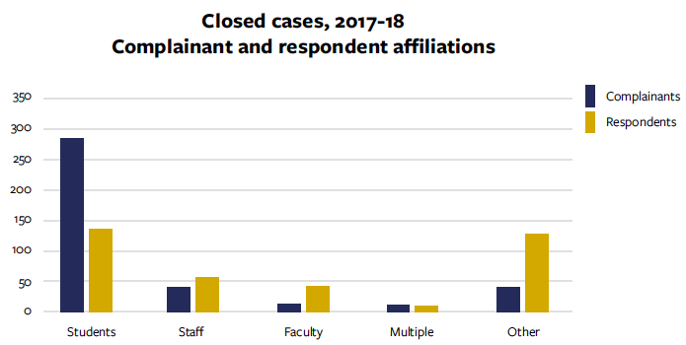

Figure 12: cases closed by OPHD in 2017-18 (380), by resolution type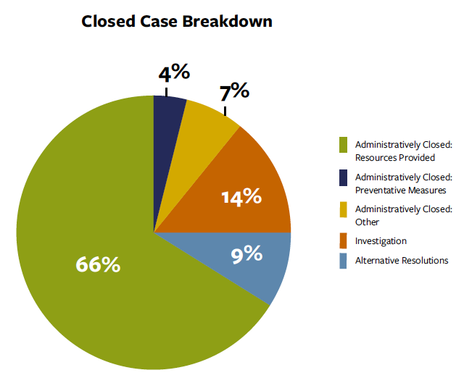

8.6. Cases closed by OPHD
Upon completion of an OPHD investigation, the OPHD report is provided to the relevant adjudicator, as described in section 7.4.
In 2017-18, OPHD completed 33 investigations of student respondent cases, making findings in 20 of them. Most of these (13) resulted in disciplinary sanctions; in five cases, the student conduct process imposed no sanctions. Two cases were still in progress as of the end of the reporting period.
In 2017-18, OPHD completed 18 investigations of staff respondent cases, involving 21 respondents (several cases had more than one respondent), making findings in 13 of the cases. Sanctions were imposed in 12 of those 13 cases. OPHD completed two investigations of cases involving faculty respondents during 2017-18; one case resulted in a finding and the other did not. The case that resulted in a finding was still in the adjudication phase at the end of the reporting period.
Future reports will provide information about time to completion for both the investigation and the adjudication of cases originating with OPHD (see section 7.6), but that data is not fully available for the 2017-18 reporting period.

Figure 13: investigation and adjudication outcomes for student respondent cases, 2017-18
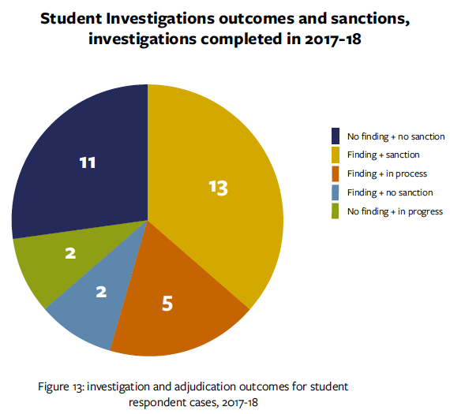

Figure 14: investigation and adjudication outcomes for staff and faculty respondent cases, 2017-18

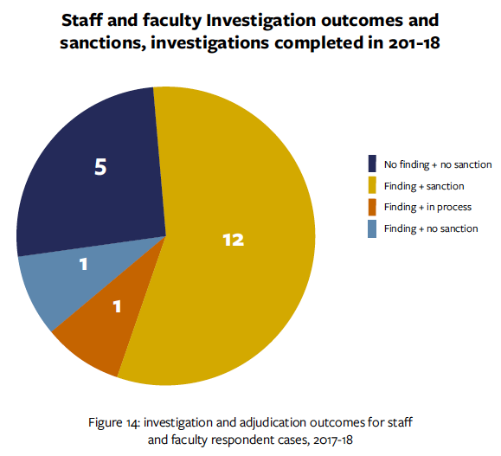

9.0. Remediation and Restoration
Disciplinary outcomes are one way of measuring accountability, but the impact of SVSH harm does not end once a disciplinary decision has been reached. This section explores the topic of remediation efforts after an incident has occurred and the affected community needs to recover.
There are numerous ways individuals and communities can work towards healing in addition to, or instead of, traditional discipline. One method of handling cases without a disciplinary action is through the kind of Alternative Resolution that OPHD can broker, in which all parties come to an agreement on steps to be taken to remedy the situation without a formal investigation.
The National Academy of Sciences 2018 Consensus Study Report, Sexual Harassment of Women Climate, Culture, and Consequences in Academic Sciences, Engineering, and Medicine, articulates that in order to be truly survivor centered, campuses need to have multiple options for survivors, beyond the traditional reporting with hopes of punitive measures. Activists on and off campus have called for options beyond punishment that aim towards re-education, reduction in recidivism, and possible reintegration. A panel discussion sponsored by UC Berkeley’s Social Science Matrix (matrix.berkeley.edu), in 2018-19, will specifically address the question of how, if at all, reintegration of the perpetrator in SVSH cases has a role in the healing of communities.
The campus does provide other kinds of remediation options for specific types of situations. For example, in addition to providing survivor support, certain Social Services staff work specifically with students who have caused physical or emotional harm. These counselors provide support and psycho-education to students who have caused harm to others and are interested in working towards positive behavioral change. PATH to Care’s confidential advocates have held healing workshops for communities where harm has occurred. These facilitated discussions acknowledge that effect violence has on the community that a respondent or complainant belongs to, and pave the way for reshaping of norms and expectations going forward.
One option that the National Academy of Sciences Consensus Report recommends for remediating SVSH damage is restorative justice, which highlights the community’s role in accountability, communication, and acknowledgement of the harm done to any individual impacted as well as the community as a whole. In emphasizing behavior change and accountability, restorative justice philosophies can offer healing and opportunities to change norms within intact communities. The Berkeley campus does not currently offer formalized restorative justice options through the formal SVSH investigation and adjudication process. Outside of the formalized process, and on a voluntary basis, however, restorative justice is available to parties who wish to explore it, either through the campus Center for Restorative Justice or other mediators. UC Berkeley hopes in the future to offer survivors, perpetrators, and their communities more options for recovery and remediation.

10.0. Next steps: actionable priorities
This report has presented a multi-dimensional view of SVSH prevention, incidence, and response on Berkeley's campus. Future reports will be able to track change, with this point as a baseline. Each report will outline steps that are planned; it is hoped that future reports will be able to assess whether progress has been made.
Some initiatives are already underway, based on recommendations from campus partners as well as by outside experts who have investigated or consulted with the campus. Others, to be included in the 2018-19 Annual Report, are in the process of emerging from the MyVoice survey.

10.1. Customizing prevention efforts for greatest efficacy
Improving prevention education is an ongoing goal. Efforts are currently under way to increase the number of in-person trainings available for faculty and staff and to develop an annual refresher training for all students. The campus also aspires to customize its SVSH prevention education to the needs of particular communities, with evaluation metrics to determine the efficacy of these efforts. As discussed in section 5.3., some programming is already in place that specifically addresses particular communities on our campus, including Respect is Part of Research, Train the Trainer participants, Greeks Against Sexual Assault, PATH to Care Peer Educators, Bears That CARE, Gender Equity Resource Center trainings, UHS SHEP program, UHS Health Worker Program, Manbassadors, etc.. In addition to evaluating this programming for consistency and efficacy, it needs to be expanded to reach more historically marginalized groups (as characterized, e.g., along the dimensions of gender identity, sexual orientation, race, ethnicity, national origin, immigrant status, (dis) ability, and more).

10.2. Confidential Resource Designation
Currently, five offices on campus are Confidential Resources as defined in the SVSH Policy. However, a number of stakeholders have recommended the establishment of a documented process or procedure for campus designation of Confidential Resources, with the goal of making the services acessible to a greater number of people. The designation of the Gender Equity Resource Center as confidential is currently in process. With suitable training and experience, others may follow.

10.3. Adjudicator training
The UC Policy on SVSH requires all who play a role in the campus adjudication process for SVSH cases to be trained on trauma- informed perspectives. Our campus recently developed a training course and provided it to over 30 adjudicators who play a role in cases with student, staff, and faculty respondents. OPHD, UCPD, and PATH to Care Center all contributed to this effort.
Next steps include assessing the training and its effects on the process overall, improving the education for adjudicators when it is offered again, and sharing the content with other campuses for their use and feedback.

11.0. Appendix

List of abbreviations
Abbreviation | Name
APM | Academic Personnel Manual
APO | Academic Personnel Office
ASUC | Associated Students of the University of California
BAWAR | Bay Area Women Against Rape (off campus)
BTC | Bears That CARE
CANRA | California Child Abuse and Neglect Reporting Act
CHRO | Chief Human Resources Officer
CMT | Case Management Team
CSC | Center for Student Conduct
CWG | Consent Working Group
EVCP | Executive Vice Chancellor and Provost
GenEq | Gender and Equity Resource Center
HR | Human Resources

List of abbreviations (con’t)
Abbreviation | Name
IPV | Intimate Partner Violence
NABITA | National Behavioral Intervention Team Association
NAS | National Academy of Sciences (off campus)
OMP | Senate Faculty Ombudspersons
OPHD | Office of Prevention of Discrimination and Harassment / Title IX
PtC | PATH to Care Center
SAO | Student Advocate’s Office
SVC | Sexual Violence Commission
SVSH | Sexual Violence and Sexual Harassment
UC | University of California
UCPD | University of California Police Department
UHS | University Health Services
VPF | Vice Provost for the Faculty

Acknowledgments
This report could not have been completed without the able assistance of Amber Zeise, Special Projects Assistant to the Special Faculty Advisor to the Chancellor on Sexual Violence/Sexual Harassment. Special thanks are also due to the many colleagues on campus who contributed data and edits, including:
- Heather Archer
- Rodney Butler
- Wanda Ellison-Crockett
- Andrew Eppig
- Joy Evans
- Ben Fils
- Paula Flamm
- Sarah Gamble
- Janet Gilmore
- Khira Griscavage
- Esther Gulli
- Diana Harvey
- Mari Knuth-Bouracee
- Therese Leone
- Becca Lopez
- Erin Niebylski
- Denise Oldham
- Paula Raffaelli
- Elliot Sosa
Copyright © 2018 UC Regents; all rights reserved

See, e.g., National Academies of Sciences, Engineering, and Medicine. 2018. Sexual Harassment of Women: Climate, Culture, and Consequences in Academic Sciences, Engineering, and Medicine. Washington, DC: The National Academies Press. https://doi.org/10.17226/24994.
http://www.ab1825.com
Centers for Disease Control and Prevention (2014). Preventing sexual violence on college campuses: lessons from research and practice.
Gidycz, C. A., Orchowski, L. M., & Berkowitz, A. D. (2011). Preventing sexual aggression among college men: An evaluation of a social norms and bystander intervention program. Violence Against Women, 17(6), 720-742. https://doi.org/10.1177/1077801211409727
Berkeley Office of Planning and Analysis, https://opa.berkeley.edu/campus-data/uc-berkeley-quick-facts
National Academies of Sciences, Engineering, and Medicine. 2018. Sexual Harassment of Women: Climate, Culture, and Consequences in Academic Sciences, Engineering, and Medicine. Washington, DC: The National Academies Press. https://doi.org/10.17226/24994.

