University of California

2022 Annual Report on Sexual Violence and Sexual Harassment (SVSH): Data Update

Table of Contents
1. Introduction
2. Incoming SVSH reports to OPHD: 2021-2022
2.1. Types of SVSH allegations
2.2. SVSH Allegations by Population
2.3. Who reported SVSH allegations to OPHD
2.4. How reports were made to OPHD
2.5. Incoming OPHD report trends by time of year
3. SVSH cases closed by OPHD: 2021-2022
3.1. Outcomes: Reports closed by OPHD in 2021-2022
3.2. Possible outcomes of an OPHD case
3.3. Reasons for closing a case after initial assessment
3.4. Outcomes of attempted alternative resolutions and investigations
3.5. Outcomes of formal investigation
3.6. Requests for supportive measures made by OPHD
3.7. Outcomes of sanctioning decisions, 2021-2022
3.8. Durations of investigation and adjudication phases
3.9. “DOE-covered” investigations and adjudications
4. Utilization of confidential resources
4.1. Reasons (types of SVSH harm) for Social Services support, 2021-2022
5. Multiple lenses on SVSH Incidence: Trends over time
5.1. OPHD Trend in SVSH reporting: 2018-2022
5.2. Types of SVSH allegations reported to OPHD: 2017-2022
5.3. Social Services Trends: 2018-2022

Introduction
UC Berkeley began issuing Annual Reports on Sexual Violence and Sexual Harassment in 2017, at the directive of Chancellor Carol Christ. To date, four such reports have been issued. They can be found in the “Data” section of the campus SVSH “hub” website, svsh.berkeley.edu.
Each Annual Report has presented a detailed mosaic of campus partners who play a part in preventing and responding to SVSH. The narrative is designed to help readers comprehend the whole, as part of a broader effort to build a culture at UC Berkeley that is based on respect, inclusivity, and equity of experience. In addition to describing campus policies, trauma-informed procedures, resources, and values, each report has offered updates on changes to law and university policy as well as descriptive statistics that offer insight into SVSH prevalence rates and access to support services during the previous academic year.
As the campus infrastructure has stabilized and awareness has increased, the campus is shifting to a new format in which Annual Reports will alternate with briefer data and policy updates. This is the first such update. It focuses on descriptive statistics regarding SVSH incidence, affording the reader visibility into how the Covid pandemic affected prevalence and response.
As always, we thank our many campus colleagues (students, staff, and faculty) for their hard and heartfelt work to make the campus a better place for all. We hope that you, the reader, will find useful information in this briefer report.
Each SVSH Annual Report is a snapshot depicting one academic/fiscal year. The 2022 SVSH Annual Report Data Update covers the time period of July 1, 2021 - June 30, 2022.
Please note the data in this report is not suitable for tracking the progression of individual cases.

Incoming SVSH reports to OPHD: 2021-2022
During the 2021-2022 academic year, the Office for the Prevention of Harassment and Discrimination (OPHD) received a total of 672 reports regarding policies the department oversees, primarily sexual violence and sexual harassment (SVSH) protected category discrimination and harassment.
A subset of these reports (454, or 68%) alleged SVSH, i.e. sexual assault, dating or domestic violence, sexual harassment, stalking, sexual exploitation, or other forms of conduct prohibited by the UC Policy on SVSH.
To understand how this number of incoming SVSH reports fits into the trend over time, please refer to the "OPHD trends: 2018-2022" section of this data update.

Types of SVSH allegations
A single report to OPHD may contain several allegations. For this reason, the 454 SVSH reports OPHD received in 2021-22 contained 504 SVSH allegations. Of these, sexual harassment was the most frequently reported, making up 37.1% of the total. Sexual assault was the second most common SVSH allegation reported to OPHD (35.7%), followed by relationship violence, stalking, and other prohibited conduct (refer to the accompanying figure).
*Note: Sexual exploitation is a form of conduct prohibited by the UC SVSH Policy. In the accompanying figure, sexual exploitation is included in the category of “Other Prohibited Conduct” with behaviors such as the invasion of sexual privacy and retaliation.
To understand how this composition of allegations fits into the trends over the years, please refer to the "OPHD trends: SVSH allegations reported to OPHD, 2017-2022" section of this data update.
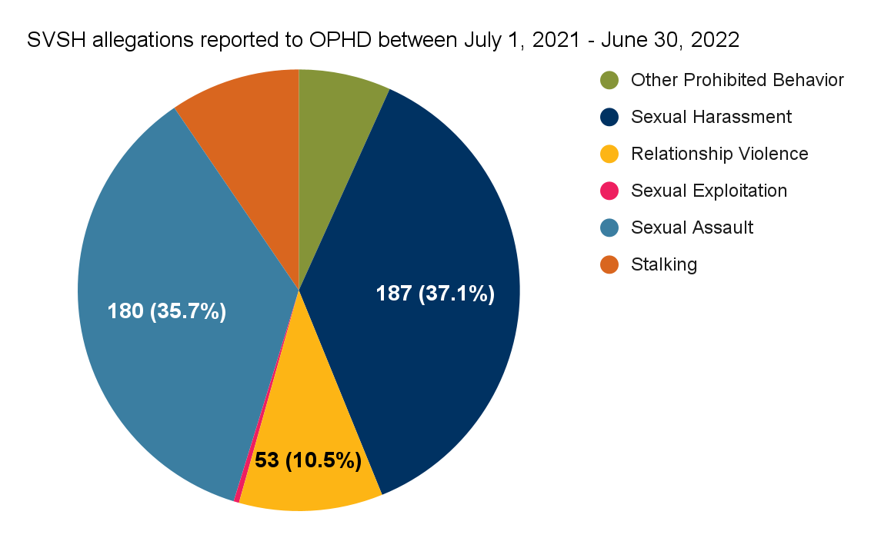

SVSH Allegations by Population
The nature of SVSH allegations varied by the status of the complainant (the impacted party). For complainants who were employees, most SVSH allegations involved sexual harassment. For complainants who were students, sexual assault was the most common SVSH allegation, followed closely by sexual harassment. These patterns, shown in the accompanying chart, are similar to what has been observed in past years.
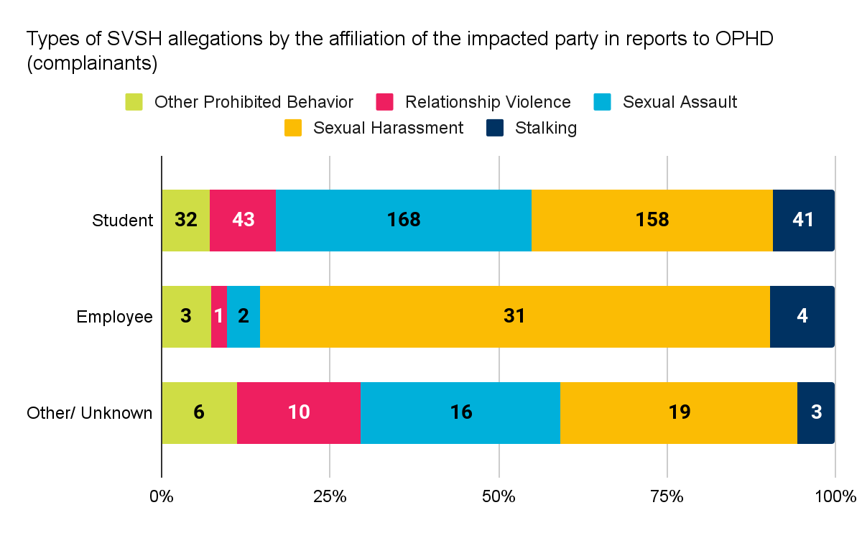
In order for the University to carry out a resolution process, there must be a nexus between the alleged conduct and the University. If the conduct alleged in a report to OPHD did not occur in the context of a University program or activity and involved only third parties, OPHD does not have the authority to carry out a resolution process. The Other/Unknown category in the accompanying figure encompasses a number of situations, such as reports in which the affiliation of the parties in the alleged incident were unknown to OPHD or the complainant (impacted party) in the alleged incident was not affiliated with UC Berkeley, but the respondent was.

Who reported SVSH allegations to OPHD
As in previous years, most (64.5%) of the SVSH reports made to OPHD came from Responsible Employees, i.e. from campus employees who are fulfilling their requirement to share with OPHD any information they learn about SVSH that is experienced by a student. (Campus employees in supervisory roles have extra responsibilities; they are required to report SVSH that is experienced by employees as well as by students.) Only 14% of reports were made directly by complainants, i.e. by those who experienced the incidents being reported. In 21% of cases, a so-called “third party,” for example, a student with no reporting obligations, made the report to OPHD.
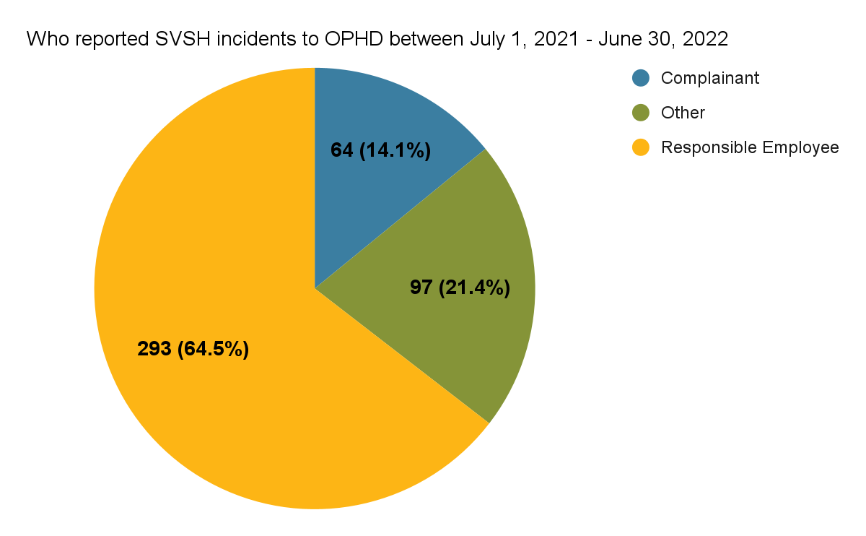

How reports were made to OPHD
In 2021, OPHD launched a new method of filing any kind of report — an online webform. The online webform quickly became the most utilized form of reporting SVSH. Email was the second most popular form of reporting, followed by phone.
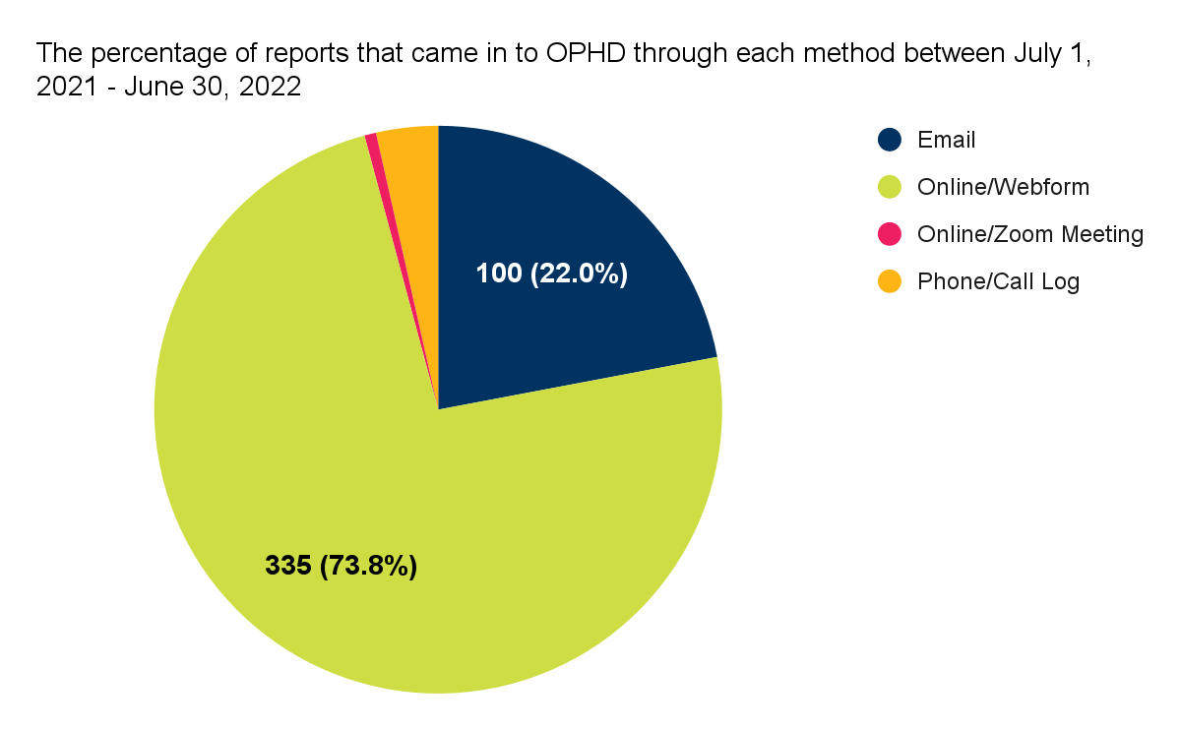

Incoming OPHD report trends by time of year
As has been the case since Annual Report tracking began, the number of reports made to OPHD spiked in the middle of each semester. Though SVSH reports are a subset of all OPHD protected category harassment and discrimination reports, the month-to-month trends are the same.
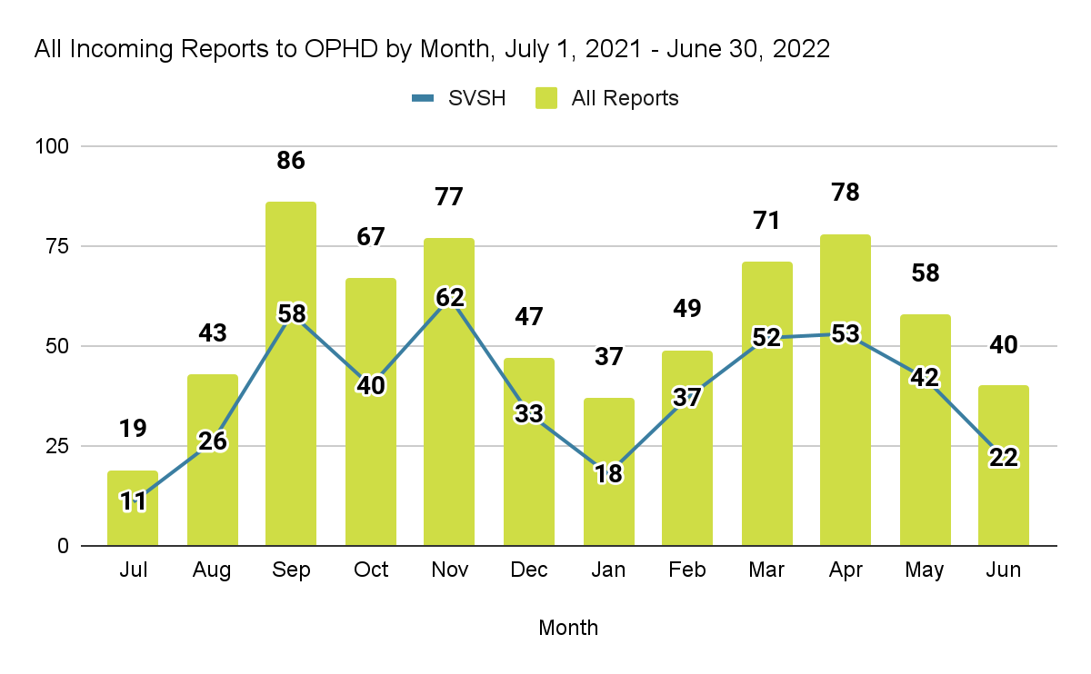

SVSH cases closed by OPHD: 2021-2022
In the interest of illuminating the degree to which the campus is able to hold campus community members accountable, this section illustrates the outcomes of SVSH cases that were reported to the Office for the Prevention of Harassment and Discrimination (OPHD).
Please note that this data is not suitable for tracking particular cases.

Outcomes: Reports closed by OPHD in 2021-2022
Once an SVSH allegation has been reported to OPHD, the formal administrative response process can begin. The outcomes of this process are often looked to as an indicator of campus accountability, and are thus carefully tracked. This section tracks outcomes of those cases closed by OPHD in 2021-2022. (Note that a case may be opened in one academic year and closed in another. Thus it is not possible to establish a one-to-one correspondence between the cases closed in 2021-2022 and those opened in 2021-2022, nor with those opened in 2020-2021.)
Between July 1, 2021 - June 30, 2022, OPHD closed 463 SVSH cases.

Possible outcomes of an OPHD case
After an initial assessment of alleged facts, OPHD has a number of options:
- Close the case after the initial assessment
- Initiate an Alternative Resolution
- Initiate a Formal Investigation
- Refer to “Other Inquiry” process
In the 2021-2022 academic year, the great majority (92.2%) of cases were closed following initial assessment (accompanying figure).
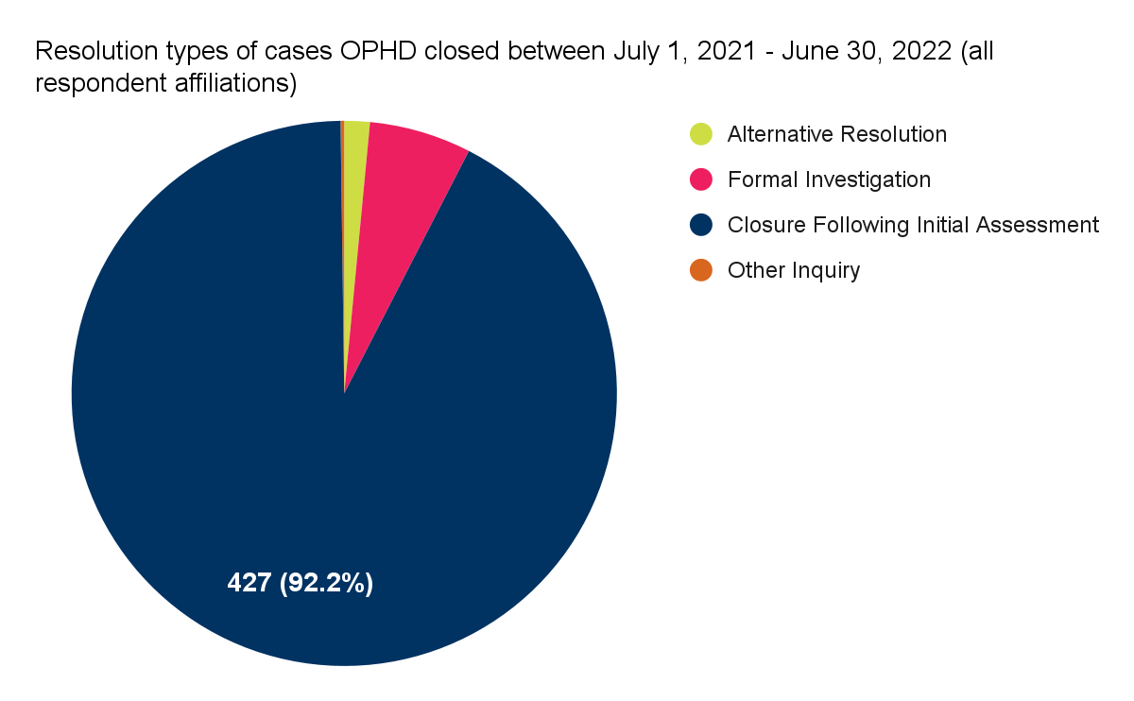

Reasons for closing a case after initial assessment
There are a number of reasons why an OPHD case may be closed following an initial assessment. The most common reason for this in 2021-2022 was that OPHD did not have sufficient information to move forward (see accompanying figure). This can happen for a variety of reasons; for example, if the complainant does not respond to OPHD’s initial outreach, or the report did not contain sufficient information for OPHD to act on.
The second most common reason for a closure following initial assessment in 2021-2022 was that the complainant requested no investigation. (A common misconception is that once a report is made to OPHD, a complainant must participate in an investigation. This is not true. As the figure shows, complainants are given options. Many complainants decide they do not want a formal investigation.)
Other reasons for a closure following initial assessment include: the alleged conduct reported to OPHD, if true, would not be a violation of university policy, or the university does not have the jurisdiction to act on the complaint.
Note: There can be more than one reason for a case being closed following an initial assessment. 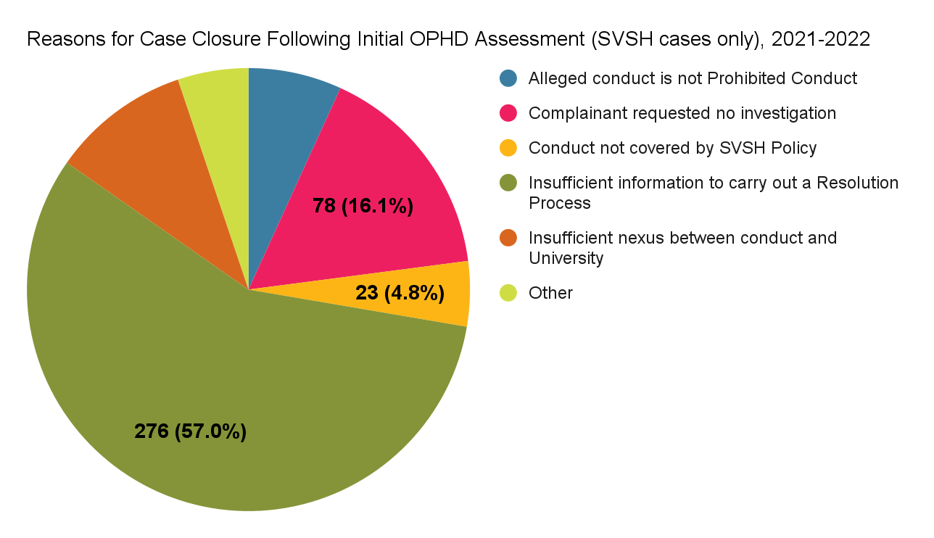

Outcomes of attempted alternative resolutions and investigations
Not all attempts to resolve a matter through alternative resolution are successful. An alternative resolution is unsuccessful in the case that a resolution is proposed to both of the parties and the parties cannot agree on the terms. In those cases, the complainant is given the choice to request a formal investigation or to not pursue the matter further.
Only one attempt at an alternative resolution was unsuccessful in 2021-22. Three investigations were administratively closed.
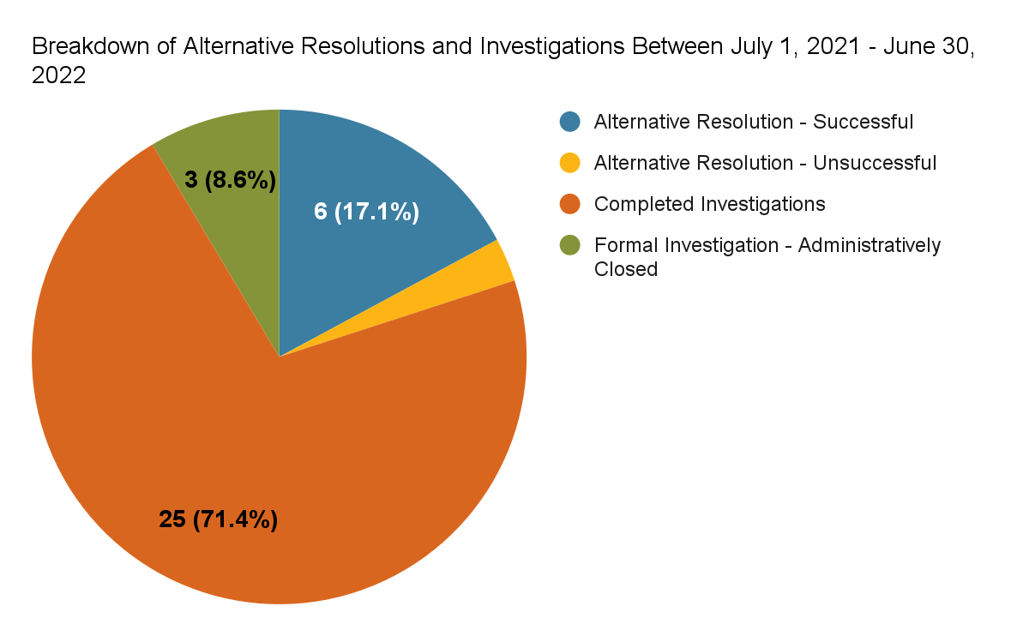
For an explanation of Alternative Resolution, please see section 8.2.2 of the 2020-2021 SVSH Annual Report.

Outcomes of formal investigation
Out of the 25 total SVSH investigations completed between July 1, 2021 and June 30, 2022, most resulted in a preliminary determination of a policy violation There were 14 SVSH cases involving student respondents and in 10 of those cases (71%), a preliminary determination of a policy finding was made. In the 11 cases involving employee respondents (academic and non-academic employees), 7 (63%) resulted in a preliminary determination of a policy violation.
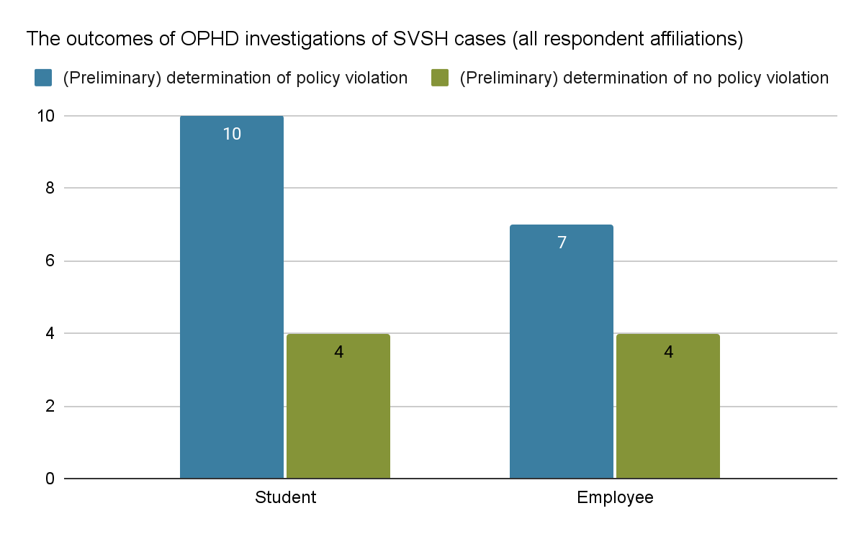
For an explanation of the steps involved in a formal OPHD investigation, please see section 8.2.3 of the 2020-2021 SVSH Annual Report.

Requests for supportive measures made by OPHD
The Office for the Prevention of Harassment and Discrimination may request supportive and remedial measures on behalf of the parties. In the 2021-22 academic year, OPHD staff requested 19 academic supportive measures, 70 no-contact directives, and 2 pregnancy accommodations.
To learn more about the kinds of supportive measures OPHD may request on behalf of a student, and the other campus offices that can also make such requests, please see sections 5.1 and 6.1.4 of the 2020-2021 SVSH Annual Report.

Outcomes of sanctioning decisions, 2021-2022
If a respondent is found responsible for a policy violation, sanctions may be put in place through an adjudication process. Between July 1, 2021 and June 30, 2022, sanctions were assigned in 76.5% of cases involving student respondents for which there was a preliminary determination of a policy violation (see accompanying figure). In cases with employee respondents, 50% of cases resulted in sanctions.
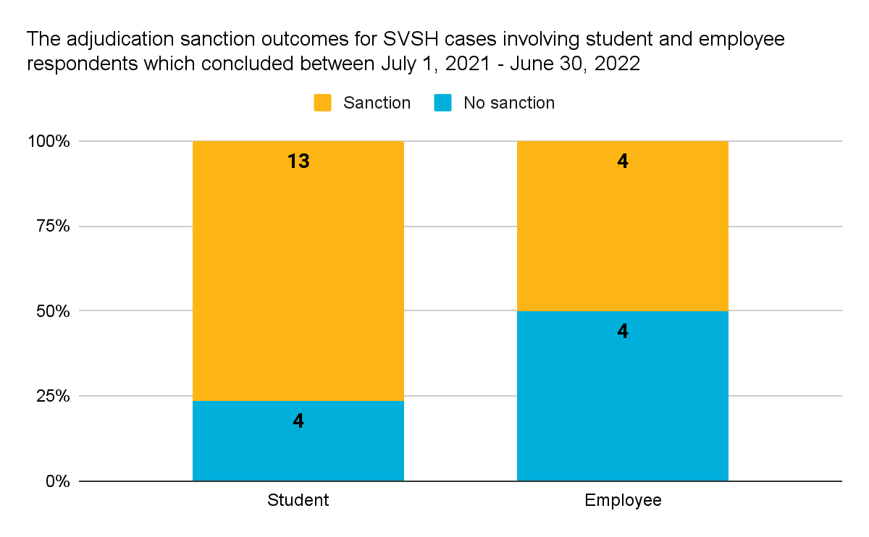
Adjudication, or sanctioning, works differently for students and various categories of employees. For a detailed description of campus adjudication processes, please see section 8.3 of the 2020-2021 SVSH Annual Report.

Durations of investigation and adjudication phases
Investigation durations are calculated in business days from when the Notice of Investigation is issued by OPHD to the date a completed investigation report is issued. Adjudication durations represent the duration of the following period, ending with the issuance of a sanctioning decision (including the outcome of an appeals process, if any, in student respondent cases).
In 2021-2022, the median duration of investigations of SVSH matters involving student respondents was 121 business days. The adjudication of cases involving student respondents took slightly less time at 119 days (median). Investigations involving employee respondents took a median of 91 business days to complete, while adjudications took a median of 42 business days.
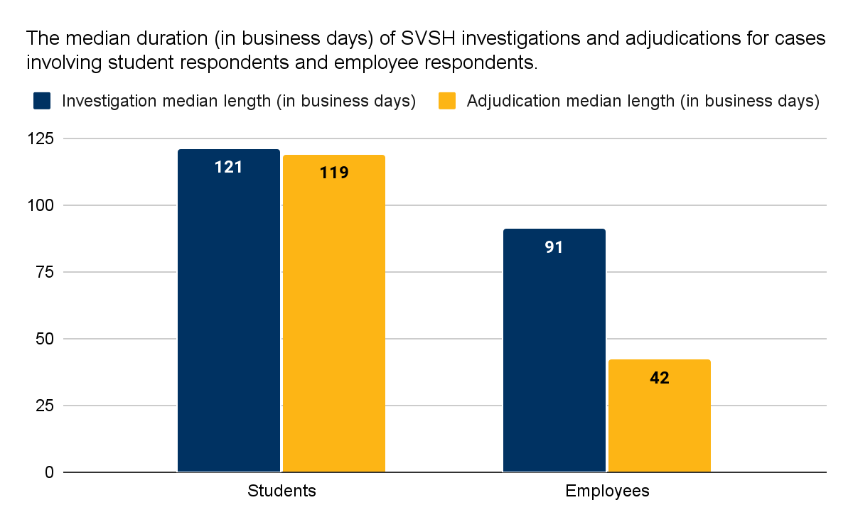

“DOE-covered” investigations and adjudications
In August 2020, in compliance with changes introduced into the regulations associated with federal Title IX legislation, the UC Policy on SVSH incorporated new investigation and adjudication procedures specific to cases involving allegations of conduct meeting the definition of Department of Education (DOE)-Covered. These so-called “DOE-covered” cases made up 32% of all SVSH cases investigated by OPHD.
To learn more about DOE-covered conduct and associated administrative procedures, please see sections 2.1.2 and 8.2.5 of the 2020-2021 SVSH Annual Report.

Utilization of confidential resources
Since 2018, each Annual Report has tracked the utilization of the two confidential campus resources dedicated to SVSH: the PATH to Care Center (which serves survivors of SVSH, whether they are students, staff, faculty, or visitors); and Social Services (which serves students who are survivors or who have caused SVSH harm).
Please note that PATH to Care Center data was not available for the 2022 SVSH Annual Report.
For descriptions of the PATH to Care Center and Social Services, please see the 2020-2021 SVSH Annual Report.

Reasons (types of SVSH harm) for Social Services support, 2021-2022
In the 2021-22 academic year, the majority of clients seen by Social Services for reasons related to SVSH came due to experiences of sexual assault (51%). Interpersonal violence (dating or domestic violence) was the second most common reason, making up 24.6% of unique clients who were seen by Social Services for SVSH. At Social Services, stalking and sexual harassment are categorized together and made up 11% of clients. A fourth category, "sexual violence" made up almost 14%.
Note: Clients may seek support from Social Services for multiple reasons. For that reason, the number of reasons or types of harm for which clients sought care from Social Services is more than the overall total number of clients Social Services saw for SVSH.
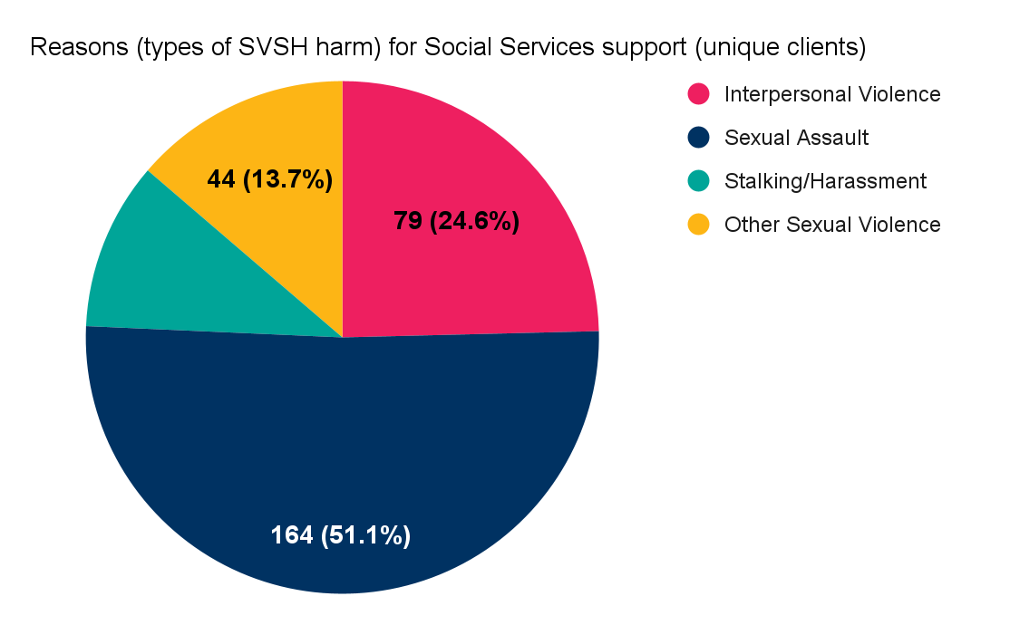
This composition of reasons for seeking Social Services support is consistent with previous years:
- In the 2018-19 academic year, 75% of all SVSH-related appointments (including appointments with survivors and respondents) were for survivors who had experienced sexual assault. Interpersonal violence (harm related to intimate partner or domestic violence) was the second most common reason for Social Services appointments, followed by sexual harassment and stalking.
- In 2019-2020, 55% of all SVSH-related appointments (including appointments with survivors and respondents) were for sexual assault. Interpersonal violence (harm related to intimate partner or domestic violence) was the second most common reason for Social Services appointments (21%), followed by sexual harassment and stalking.
- In 2020-2021, 28% of all SVSH-related appointments at Social Services (including appointments with survivors and respondents) were for sexual assault. Intimate partner/ domestic/dating violence was the second most common reason for Social Services appointments (14%), followed by sexual harassment and stalking (2.5%). The rest were coded by Social Services as “Trauma.”

Multiple lenses on SVSH Incidence: Trends over time
Since 2018, the SVSH Annual Reports (of which this is the fifth) have enabled the exploration of trends over time and, consequently, a deeper understanding of the impacts of SVSH in our communities. The true incidence of SVSH is hard to assess, since many incidents are not reported. Annual Reports have triangulated on SVSH prevalence rates by looking at data from multiple sources: OPHD reports, UCPD reports, utilization of confidential campus resources, and survey results. In this year’s data update, only OPHD reports and confidential resource utilization are tracked.

OPHD Trend in SVSH reporting: 2018-2022
As seen in the accompanying figure, the 2021-2022 academic year saw a spike in SVSH cases reported to OPHD, slightly higher than the total in 2018-19, the first year to be covered by an SVSH Annual Report. As was discussed in the 2021-22 Annual Report, the lower reporting figures for the two intervening years are likely due to the COVID-19 pandemic. Due to shelter-at-home orders in March 2020, the number of students (and employees) living and working on campus dropped dramatically, only returning to pre-pandemic levels in the summer of 2021. Setting aside the pandemic years, then, the comparison between 2018-19 and 2021-22 reveals a small increase in reports. (Figures for 2017-2018 were comparable to those for 2018-2019, but are not shown in the accompanying graph due to differences in how data was quantified at the time.)
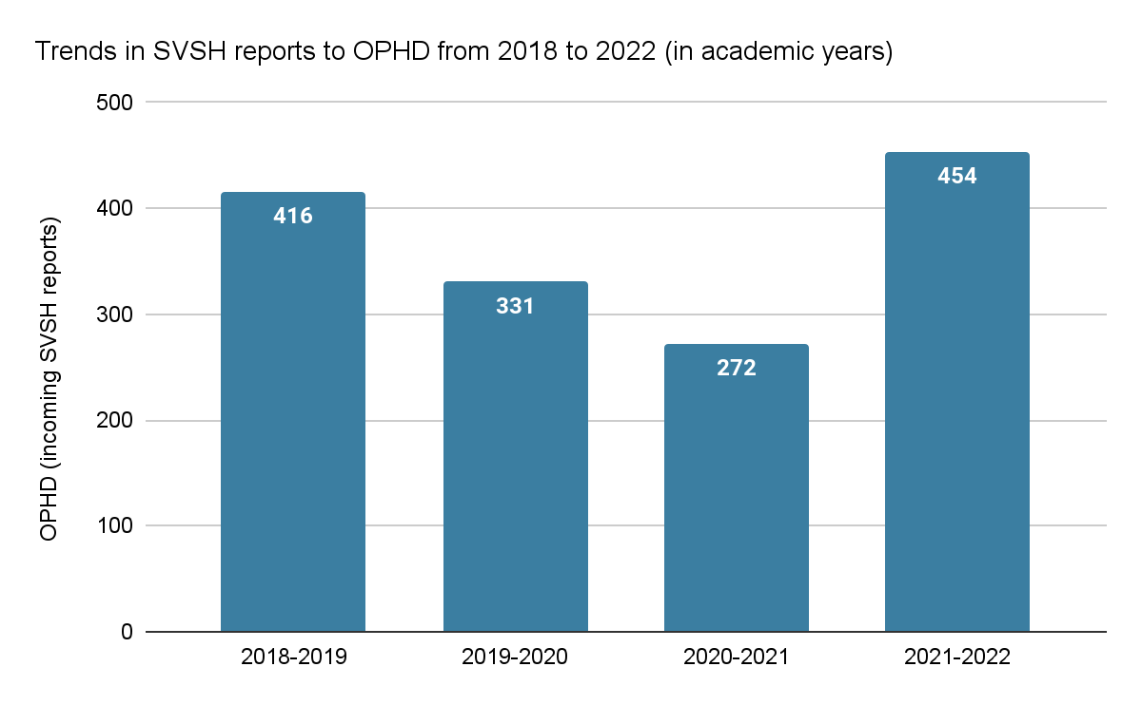
As discussed in previous Annual Reports, an increase in reports to OPHD may reflect an increase in awareness of and confidence in the reporting mechanism, or an increase in actual incidents, or both.

Types of SVSH allegations reported to OPHD: 2017-2022
Sexual harassment has generally been the most common allegation reported to OPHD since Annual Report tracking began in 2017-2018. As the accompanying figure shows, reports of sexual harassment dropped dramatically during the 18 months during which campus instruction and work was largely remote and individuals were not in proximity to one another. By comparison, reports of relationship violence spiked in 2020-21, when individuals were sheltering from the pandemic and had less freedom to leave unsafe living situations. An emergent trend in the 2021-22 data, compared to all three previous years, is the increase in reports of sexual assault and stalking, which points to the need for renewed social norms campaigns and education for the community. It may be that a period of nearly two years without the kind of in-person social interactions that had, pre-pandemic, been the norm, led to a decrease in understanding of respectful interactions, consent, and boundaries.
Note: In the 2018 SVSH Annual Report, which covered July 1, 2017 - June 30, 2018, “SVSH unspecified” and “retaliation” were included as their own categories. For the purposes of comparison across years, these two categories were added to the “Other Prohibited Conduct” category.
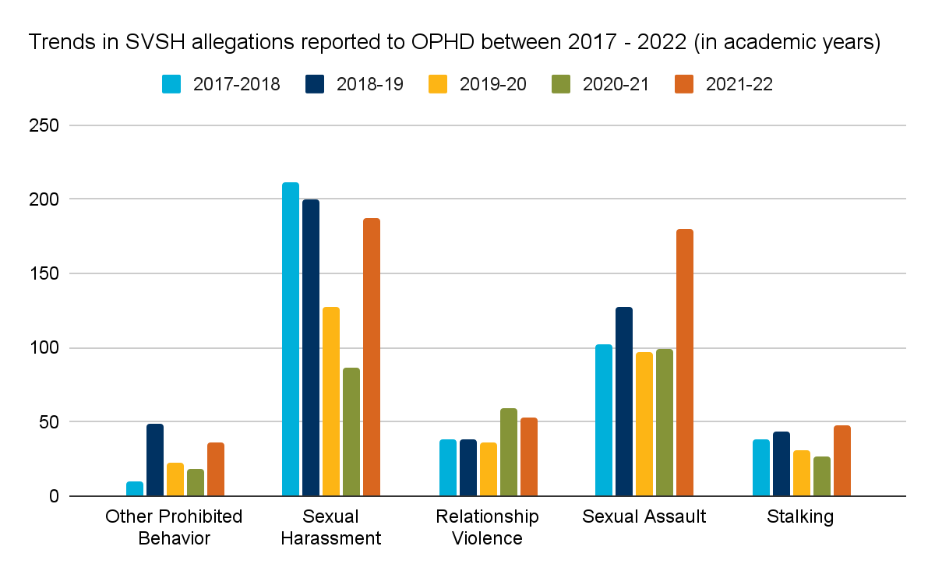

Social Services Trends: 2018-2022
Social Services saw a marked decrease in clients who sought services for SVSH (refer to the accompanying figure). In 2021-2022, Social Services supported 103 survivors of SVSH (321 appointments total) and provided counseling to 3 respondents (4 appointments). (In past years, the proportions of survivors and respondents were not broken out in the data, but were likely quite similar, with the majority of clients being survivors.)
Social Services believes the decrease in the number of clients who sought services for SVSH is due to a decrease in the unit’s staffing, which led to fewer appointments offered. Since the 2021-22 academic year, Social Services has increased their staff.
Note that in the 2018, 2019, 2020, and 2021 SVSH Annual Reports, respondents were included in the total number of clients Social Services saw for reasons related to SVSH. In 2021-22, respondents are broken out from the total, but included in the same bar.
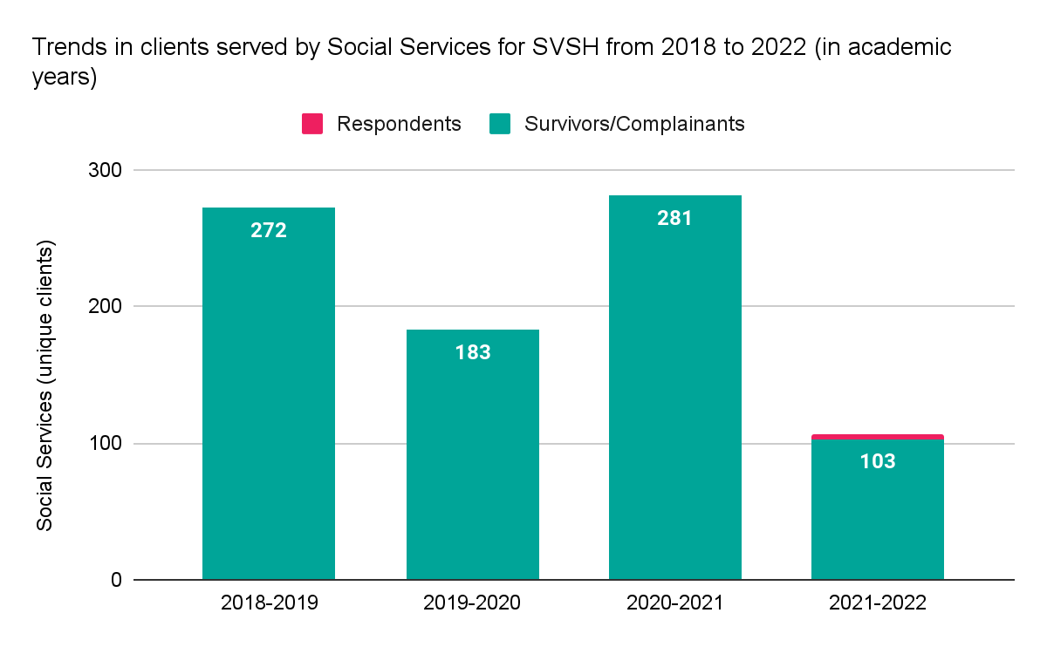

Sexual exploitation is defined in the UC SVSH Policy as “taking sexual advantage of another, where the conduct is not otherwise addressed in this Policy, in the following circumstances: a) The trafficking or prostituting of another without their consent: Inducing the Complainant to perform a commercial sex act through force, fraud, or coercion, or where the Complainant is under the age of 18; b) Knowingly making a material false representation about sexually transmitted infection, birth control, or prophylactic status with the specific intent and effect of inducing the Complainant to participate in a specific sexual act or encounter; c) Providing alcohol or drugs to the Complainant with the specific intent and effect of facilitating Prohibited Conduct; or d) Actively facilitating or assisting another person in committing Prohibited Conduct.”
According to the UC Policy on Sexual Violence and Sexual Harassment, the “Title IX Officer may close an investigation before completing it if they determine that a significant change in circumstances has so substantially impaired the investigation that they cannot reach reasonably reliable conclusions about whether the alleged conduct occurred. The Title IX Officer will still, when appropriate, take steps to stop the reported conduct, prevent its escalation or recurrence, and address its effects. They will also offer as appropriate resources to the parties and Mitigating Measures to the Complainant.”

